Reviews
Average item review
5 out of 5 stars
(294)

Lisa Harris on May 27, 2017
5 out of 5 stars
The quality and beauty of your work is outstanding! Even more beautiful in person than in pictures. Will be ordering more.

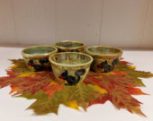

Squirrel Bowl, Handmade Pottery Bowl, Wild Crow Farm Pottery

Kathy Robinson on May 23, 2017
5 out of 5 stars
This is my favorite mug for my morning coffee. I accidentally knocked the last one off the kitchen table and broke it. So glad I could buy another one. She makes the best mugs!

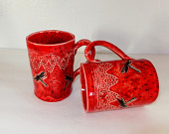

Large Red Dragonfly Coffee Mug, Hand Built Ceramic Pottery Mug, Wild Crow Farm Pottery

Rachel Beaton on May 13, 2017
5 out of 5 stars

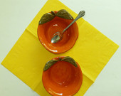

Orange Ceramic Bowl, Rustic Stoneware Citrus Bowls, Wild Crow Farm Pottery

TanteiCat on May 12, 2017
5 out of 5 stars
There was an inexplicable shipping accident, but they remade the jar even better than before and sent it. Extremely happy with the jar and the attentive service.

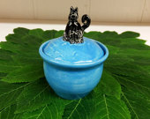

Itty Kitty Handmade Ceramic Jar, Wild Crow Farm Pottery
TanteiCat on May 12, 2017
5 out of 5 stars
Beautiful and just perfect. Fast shipping, good customer service.

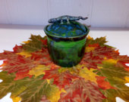

Summer Lizard Jar, Sugar Jar, Wild Crow Farm Pottery
francesy4 on May 11, 2017
5 out of 5 stars
This mug is very unique, and holds enough coffee to get me through the first 15 minutes of the day. One of my greyhounds broke my first one- I was immediately back on etsy buying another.

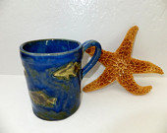

Large Blue Ceramic Fish Coffee Mug, Handmade Stoneware Pottery Mug, Wild Crow Farm Pottery
Christine Hendra on May 11, 2017
5 out of 5 stars
The open butter dish is delightful! I love the design, and the colors - it is exactly as I had imagined it. The butter dish was carefully and prettily packaged - it is evident that this artist takes pride in her work - as she should. I was pleasantly surprised at how quickly it came. Thank you!

Custom Olive Green Butter Dish with Dandelions and Poppy Impressions
looznit on May 7, 2017
5 out of 5 stars
Very nice! Thank you.

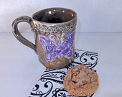

Amber Ceramic Coffee Mug with Purple Butterflies,Stoneware Pottery Mug

Dana White Owl on May 3, 2017
5 out of 5 stars

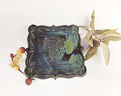

Midnight Owl Spoon Rest, Ring Holder, Ceramic Tapas Plate, Wild Crow Farm Pottery
magrange on May 2, 2017
4 out of 5 stars
Heavy but great for pasta. My cyclist son loves it!

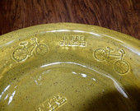

Deep Dish Pie Plate, Enjoy the Ride Biker's Handmade Ceramic Stoneware, Wild Crow Farm Pottery
magrange on May 2, 2017
5 out of 5 stars
Small, solid, cute design -- just right for small dishes.

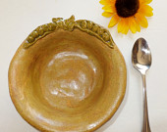

Pea Bowl, Rustic Handmade Stoneware, Spring Pea Bowl, Wild Crow Farm Pottery
heytherebirdie on Apr 26, 2017
5 out of 5 stars
Prettier in person! The personalized note and "about me" letter included by Julie helped me love it even more. I fell in love with this piece while between jobs last summer, marked it as a favorite, put it on the back burner amidst the distractions of life, and was more than happy to find it still available. Needless to say, I snapped this little gem right up and I'm ever so glad I did. Thank you!!!

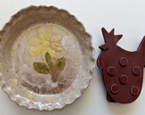

Daisy Pie Pan on Rustic White, Cake Pan, Quiche Pan

ambala on Apr 12, 2017
5 out of 5 stars
I have the whole beautiful set now and it is stunning! Thankyou so much Julie.

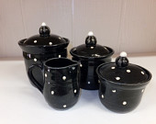

RESERVED FOR ROSY Black Polka Dot Tea and Coffee Canisters, Handmade Ceramic Pottery, Wild Crow Farm Pottery
francesy4 on Apr 5, 2017
5 out of 5 stars
This is the favorite mug in the house! It's prettier than it is in the picture.

Large Blue Ceramic Fish Coffee Mug, Handmade Stoneware Pottery Mug, Wild Crow Farm Pottery

Wendy Harold on Mar 29, 2017
5 out of 5 stars
So cute...looks like a homemade, one-of-a-kind piece made with love❤️🐿❤️

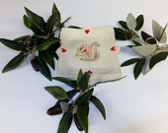

Squirrel Spoon Rest, Soap Dish, Ring Holder, Tapas Plate, Wild Crow Farm Pottery
pstunz on Mar 28, 2017
5 out of 5 stars
This mug is big and beefy and my wife loves it because she can fit every drop of coffee in it at once.

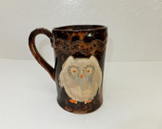

Large Owl Coffee Mug, Hand Built Ceramic Stoneware Mug, Wild Crow Farm Pottery
Clarissa Johnson on Mar 28, 2017
5 out of 5 stars
I love it, Super cute and super easy to clean after messy spoons. The size isn't super huge, but it still works well for any size spoon to keep it off of the surface.

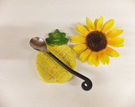

Island Pineapple Spoon Rest, Ceramic Trinket Dish, Wild Crow Farm Pottery
Darra Luciano on Mar 13, 2017
5 out of 5 stars

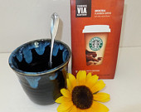

Midnight Oceans, Black and Blue Ceramic Tea Mug, Wild Crow Farm Pottery
ambala on Mar 2, 2017
5 out of 5 stars
Gorgeous as always Julie. Thankyou so much!

RESERVED FOR ROSY Black Polka Dot Tea and Coffee Canisters, Handmade Ceramic Pottery, Wild Crow Farm Pottery
Carl Johnson on Feb 28, 2017
5 out of 5 stars

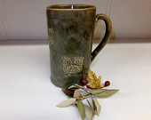

Extra Large Owl Man Size Ceramic Coffee Mug, Hand Built Stoneware, Wild Crow Farm Pottery
lynnkieliszewski4 on Feb 24, 2017
5 out of 5 stars
Tiny, but very pretty, well made--hassle free transaction & fast shipping.

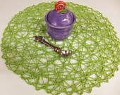

Purple Keepsake Jewelry Jar, Handmade Ceramic Pottery, Wild Crow Farm Pottery
Lynne Chin on Feb 14, 2017
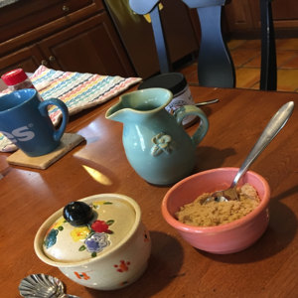
5 out of 5 stars
Beautiful! And Julie wraps the package so nicely and securely 😊 Love this talented artist's work 💕 The perfect bowl for brown sugar on oatmeal morning, and notice the world's most adorable sugar bowl next to it 😁

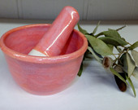

Pink Ceramic Prep Bowl with Mortar, Stoneware Pottery, Wild Crow Farm Pottery

Viv Holland on Feb 10, 2017
5 out of 5 stars

Summer Lizard Jar, Sugar Jar, Wild Crow Farm Pottery

Lindsey Garcia on Feb 10, 2017
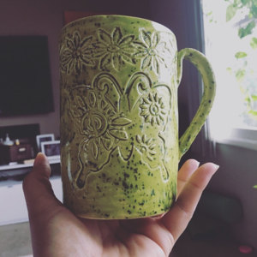
5 out of 5 stars
I'm in love!! It's beautiful!! Thank you.

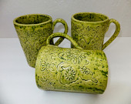

Extra Large Ceramic Butterfly Mug, Lime Green Handmade Stoneware Coffee Cup, Wild Crow Farm Pottery

meriya on Feb 3, 2017
5 out of 5 stars
Absolutely love this fun & delightful little jar! Lovingly packaged and well insulated. Thank you so much!

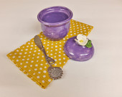

Lavender Keepsake Jar, Handmade Ceramic Pottery, Wild Crow Farm Pottery
dannynlibby on Jan 27, 2017
5 out of 5 stars
Most amazing pieces! It has been an absolute pleasure to work with this artist.

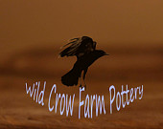

Variety of Very Fun, Beautiful Ornaments
Valerie on Jan 26, 2017
5 out of 5 stars
Super cute dish! Perfect gift for my friend. Packaged nicely and shipped super quick! Great communication by the seller!

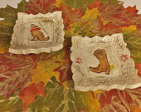

Southwest Coyote or Cowboy Boot Spoon Rest, Soap Dish,Tapas Plate, Wild Crow Farm Pottery

Theresa Stern Valentic on Jan 24, 2017
5 out of 5 stars
Very beautiful piece. The color is lighter than the photo shows but still nice looking.

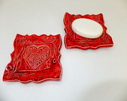

Red Heart Soap Dish, Spoon Rest, Ring Holder, Tapas Plate, Wild Crow Farm Pottery
Valerie on Jan 23, 2017
5 out of 5 stars
Super cute dish. Perfect for Valentine's decorations in my house. I will definitely use it beyond Valentine's Day. Great communication from seller. Shipped quickly and packaged nicely. So cute I ordered one for my friend's birthday!!

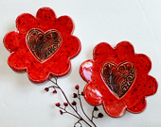

Red Heart Ceramic Trinket Dish, Ring Holder, Valentine's Day Dessert Plate, Wild Crow Farm Pottery
ambala on Jan 19, 2017
5 out of 5 stars
So adorable! I love that the dots are unglazed Julie xxx

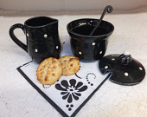

RESERVED FOR ROSY Black Polka Dot Sugar and Creamer, Handmade Ceramic Pottery, Wild Crow Farm Pottery

henningfamily1 on Jan 17, 2017
5 out of 5 stars
Item received was as described

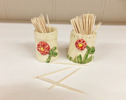

Red Flower Toothpick Holder, Wild Crow Farm Pottery
JoEllen on Jan 15, 2017
5 out of 5 stars
I ordered this to be sent as a Christmas gift. Per my request it was gift wrapped and the carton marked with the warning "Do not open until Christmas." The recipient told me it arrived safely, how well it had been wrapped, and how lovely it was. I would definitely order from this vendor again.

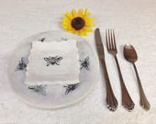

Bumblebee Plates, Hand Built Ceramic Stoneware Appetizer or Luncheon Plate, Wild Crow Farm Pottery
meriya on Jan 13, 2017
5 out of 5 stars
Fun & whimsy item! Absolutely adore this cheerful sugar jar! love one-of-kind items! Thank you so much❤️

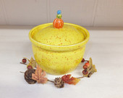

Yellow Ceramic Jar, Handmade Stoneware Pottery Sugar Bowl, Wild Crow Farm Pottery

Sophia Victoria on Jan 10, 2017
4 out of 5 stars
Unusual valentine ceramic tree ornament.

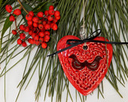

3" Red Heart Ornament, Party Favor, Ceramic Gift Tag, Valentine's Day Gift, Christmas Ornament, Wild Crow Farm Pottery
Jessica Ross on Jan 10, 2017
5 out of 5 stars
WildCrowFarmPottery, you've done it again. Beautiful work, all around. Big mugs with awesome designs. I am fully stocked with these in my cabinets and get compliments on them all the time!

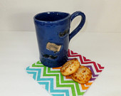

Extra Large Mustache Coffee Mug, Handmade Ceramic Stoneware Pottery Mug, Wild Crow Farm Pottery
Jessica Ross on Jan 10, 2017
5 out of 5 stars
WildCrowFarmPottery, you've done it again. Beautiful work, all around. Big mugs with awesome designs. I am fully stocked with these in my cabinets and get compliments on them all the time!

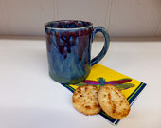

Deep Ocean Blue Coffee Mug, Wild Crow Farm Pottery
Jessica Ross on Jan 10, 2017
5 out of 5 stars
WildCrowFarmPottery, you've done it again. Beautiful work, all around. Big mugs with awesome designs. I am fully stocked with these in my cabinets and get compliments on them all the time!

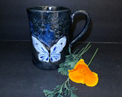

Blue Butterfly Ceramic Coffee Mug, Hand Built Stoneware, Extra Large Pottery Mug, Wild Crow Farm Pottery
Jessica Ross on Jan 10, 2017
5 out of 5 stars
WildCrowFarmPottery, you've done it again. Beautiful work, all around. Big mugs with awesome designs. I am fully stocked with these in my cabinets and get compliments on them all the time!

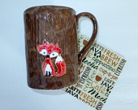

Large Ceramic Red Fox Coffee Mug In The Woods, Hand Built Stoneware Mug, Wild Crow Farm Pottery
nhgirl771 on Jan 7, 2017
5 out of 5 stars
Exceeded my expectations! Expertly crafted and well-packaged. Will order more from this seller!

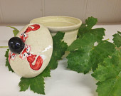

Red Fox Sugar Jar, Handmade Stoneware Pottery, Wild Crow Farm Pottery
nhgirl771 on Jan 7, 2017
5 out of 5 stars
Exceeded my expectations! Expertly crafted and well-packaged. Will order more from this seller!

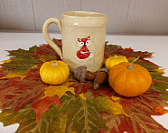

Little Red Fox Coffee Mug, Hand Built Ceramic Pottery Cup, Wild Crow Farm Pottery
Rochelle Berg on Jan 5, 2017
5 out of 5 stars
So cute! I love it!

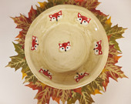

Red Fox Ceramic Deep Dish Pie Plate, Handmade Stoneware, Wild Crow Farm Pottery

Whitney George on Jan 3, 2017
5 out of 5 stars

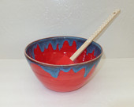

Large Electric Blue and Red Ceramic Serving Bowl, Stoneware Mixing Bowl, Wild Crow Farm Pottery

Teresa Johnson on Jan 3, 2017
5 out of 5 stars
This is absolutely beautiful. The glaze colors are elegant and the owl design was perfect for my friend. Working with Julie was easy, fun and a joy.

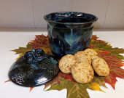

RESERVED for Teresa ~ Owl Ceramic Kitchen Canister, Handmade Stoneware Pottery, Wild Crow Farm Pottery
dannynlibby on Dec 30, 2016
5 out of 5 stars
Wild Crow Farm Pottery was extremely prompt and most helpful. The pieces are beautiful. It was a pleasure ordering from such a wonderful artist.

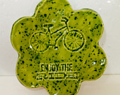

Lime Green Ceramic Spoon Rest, Soap Dish, Dipping Bowl, Trinket Dish, Enjoy the Ride, Wild Crow Farm Pottery
dannynlibby on Dec 30, 2016
5 out of 5 stars
The artist went out of her work to accommodate my special order. Plus, the amazing pieces arrived so quickly and were nicely presented (wrapped, etc.). Very impressive!

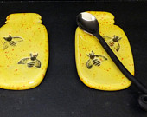

Bees in a Mason Jar Spoon Rest, Ring Holder, Wild Crow Farm Pottery
dannynlibby on Dec 30, 2016
5 out of 5 stars
I cannot properly reveal how nice it is to work with such a kind artist like Julie (with Wild Crow Farm Pottery). Not only was I able to order and receive lovely ceramic pieces from afar, but she even agreed to custom create one-of-a-kind pieces for me.

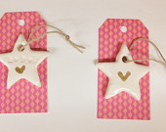

HOPE Star Ornament, Ceramic Heart Pendant, Gift Tag, Wild Crow Farm Pottery
grandmamaryville99 on Dec 27, 2016
1 out of 5 stars
It was to small and I though it was a mason clear jar I was ordering not porterhouse that can NOT be put in water.

Wild Crow Farm Pottery responded on Dec 28, 2016
Apparently a mistake was made when this item was ordered. The description, complete with photos, clearly details the dimensions and states specifically that white stoneware and red glaze are used. The description does not say that this product is glass (or slumped glass), and there is no mention of it being "porterhouse", which we assume is a beef steak. Our pottery is dishwasher safe ~ easily cleaned with water. Failure to read the description cost this shop a bad review. A refund was offered, but there was no response. It's always disappointing when a customer is unhappy.

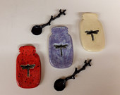

Dragonflies in a Mason Jar Spoon Rest, Ring Holder, Wild Crow Farm Pottery
Heather Onderko on Dec 21, 2016
5 out of 5 stars

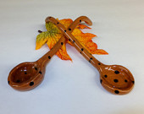

Brown Handmade Ceramic Spoon, Handmade Stoneware Pottery, Wild Crow Farm Pottery
lovercash4 on Dec 17, 2016
5 out of 5 stars

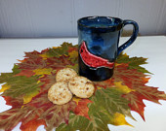

Large Red Cardinal Coffee Mug, Hand Built Ceramic Pottery Mug, Wild Crow Farm Pottery
sswharton on Dec 15, 2016
5 out of 5 stars
Very quick shipping and the spoon rest is such a beautiful shade of blue. Thank you!

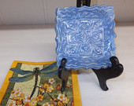

Blue Victorian Style Spoon Rest, Soap Dish, Ring Holder, Tapas Plate, Wild Crow Farm Pottery
StaceyAbraham on Dec 14, 2016
5 out of 5 stars

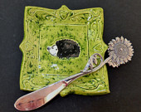

Hedgehog Spoon Rest, Soap Dish, Ring Holder, Tapas Plate, Wild Crow Farm Pottery
sulla2 on Dec 12, 2016
5 out of 5 stars

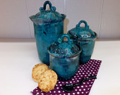

Ceramic Canister Set in Northern Ocean, Handmade Stoneware Pottery, Wild Crow Farm Pottery
giahanna2 on Dec 9, 2016
4 out of 5 stars
I love my beautiful cup

Ceramic Coffee Mug with Purple Butterflies, Hand Built Stoneware Mug, Wild Crow Farm Pottery
Lynne Chin on Dec 7, 2016
5 out of 5 stars
This is the most adorable sugar bowl ever! Love it 😍 Love it 😍 Love it 😍

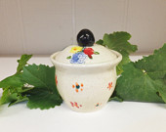

Sugar Jar with Garden Flowers, Handmade Ceramic Pottery, Wild Crow Farm Pottery

Patrick Zeke Danielson on Dec 4, 2016
5 out of 5 stars

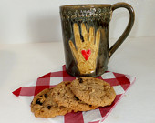

Extra Large Hamsa Ceramic Coffee Mug with Hands and Hearts, Wild Crow Farm Pottery
sulla2 on Dec 4, 2016
5 out of 5 stars

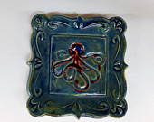

Octopus Soap Dish, Ring Holder, Tapas Plate, Spoon Rest, Wild Crow Farm Pottery
Janis Ensminger on Nov 30, 2016
5 out of 5 stars
This is a beautiful custom made canister duo that is so gorgeous!! Very well made and delivered in great packaging! They look great on my kitchen counter and I have received many complimentary remarks about them!

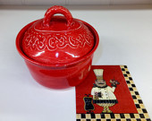

Deep Red Ceramic Jar Set, Handmade Stoneware Pottery Canisters, Wild Crow Farm Pottery

diaden2 on Nov 22, 2016
5 out of 5 stars
Sorry for my delay in getting in touch. Thank you for the very prompt shipping! The dish was beautiful,y packaged. It would be easy to give as a gift if I did not want to keep it for myself. I highly recommend you! Thank you!

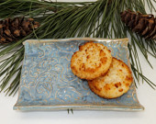

BlueScrolled Ceramic Serving Tray, Butter Dish, Hand Built Soap Dish, Wild Crow Farm Pottery
Lynne Chin on Nov 22, 2016
5 out of 5 stars
It's easy to see that this adorable little jar was made with love ❤️ There's just something about it - the shape, size and colors are just right! It arrived so beautifully wrapped too! I will be back for more of Julie's beautiful pottery! 😊

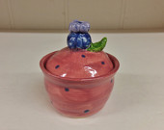

Mini Pink Jar, Handmade Ceramic Pottery Jewelry Keeper, Wild Crow Farm Pottery
monikany1 on Nov 21, 2016
5 out of 5 stars
Beautiful mug, super fast shipping. It would make a very nice gift.

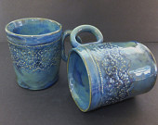

Blue Green Lace Ceramic Coffee Mug, Hand Built Stoneware Mug, Wild Crow Farm Pottery

Joan Shroyer-Keno on Nov 9, 2016
5 out of 5 stars
These wonderful canisters bring a ray of sunshine into my day each morning. The detail and quality are wonderful.



3 Bright Canisters for Especially for Joan
ambala on Nov 9, 2016
5 out of 5 stars
Gorgeous and more gorgeous! Oooh I do love your pottery Julie. SO much fun!

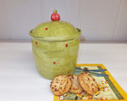

Olive and Red Ceramic Kitchen Canister, Handmade Stoneware Pottery Storage Jar, Wild Crow Farm Pottery
ThePamster on Nov 3, 2016
5 out of 5 stars
A genuine one of a kind piece. There are tree bowls available but none like this one. Beautiful, creative, an imaginative piece that was well packaged and quickly shipped. Mix in some delightful conversation and you get a perfect shopping experience.

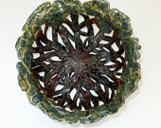

Large Decorative Oak Tree Ceramic Bowl, Colander, Wild Crow Farm Pottery

jkonsweet on Oct 27, 2016
5 out of 5 stars
We absolutely love our new mugs! We have 4 mugs from Wild Crow Farm Pottery and are pleased with each of them. Drinking coffee in the morning is essential but drinking coffee from a hand made mug makes the experience amazing!

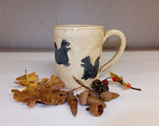

Squirrel Coffee Mug, Hand Built Ceramic Stoneware Mug, Wild Crow Farm Pottery

Bryn Miller on Oct 9, 2016
5 out of 5 stars
Beautiful,well wrapped Hand to Work ,Heart to God Cup. Love it. Thanks ,

Extra Large Hamsa Ceramic Coffee Mug with Hands and Hearts, Wild Crow Farm Pottery

tabby6957 on Oct 6, 2016
5 out of 5 stars
**JULIE'S CREATIONS ARE SO WONDERFUL**THIS BOWL HAS BEEN IN MY CART SINCE THE FIRST DAY SHE PUT IN OUT IN HER SHOP**I LOVE EACH & EVERY ONE OF HER UNIQUE PIECES OF POTTERY I HAVE IN MY HOME**THEY ARE ALL ONE OF A KIND** PRACTICAL, BEAUTIFUL, DECORATIVE, STURDY GREAT DESIGNS & MADE WITH DEDICATION**THIS ARTIST HAS A HEART OF GOLD**THANK YOU SO MUCH FOR PACKING THIS TREASURE SAFE & SOUND & GETTING IT TO ME SO QUICKLY**BLESSINGS TO YOU FOR SHARING YOUR TALENTS**YOU KNEW I WAS THE ONE WHO WOULD END UP WITH THIS PRECIOUS BOWL, DIDN'T YOU?**

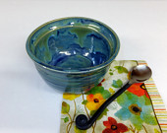

Small Ocean Blue Custard Cup, Rustic Handmade Pottery, Wild Crow Farm Pottery
mghani on Oct 4, 2016
5 out of 5 stars
This was for my wife's birthday and she loved it! Thank you for creating a beautiful piece of art.

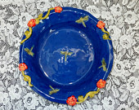

Deep Dish Dragonfly Ceramic Pie Pan, Handmade Stoneware, Wild Crow Farm Pottery

Rena McGuire on Sep 29, 2016
5 out of 5 stars
Very happy with these adorable bowls. Fast shipping

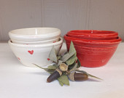

Red and White Ceramic Prep Bowl Set, Stoneware Nesting Bowls, Wild Crow Farm Pottery
Rena McGuire on Sep 29, 2016
5 out of 5 stars
Really cute nice quality and fast shipping!

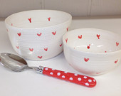

Red Heart Ceramic Bowl Set, Stoneware Nesting Bowls, Wild Crow Farm Pottery
annavenizelos on Sep 14, 2016
5 out of 5 stars
I communicated with Julie about a custom mug I had made. She was SO helpful & accommodating. The end result was perfect. I highly recommend doing business with them.



Custom 24 oz. Fox Mug in Green
Robyn Wiles on Sep 13, 2016
5 out of 5 stars
This mug is perfect. Just like the image. Shipped quickly. A 10/10 shopping transaction. Excellent communication. Helpful and thoughtful people. Again, thank you. I have had quite a few people saying - I really like your mug...

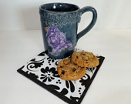

Purple Bird Ceramic Mug, Blue Pottery Coffee Cup, Wild Crow Farm Pottery
ambala on Sep 8, 2016
5 out of 5 stars
Perfect piece! I love this canister and so do my family. I'll email soon Julie for the black pieces. Thank you for adding to the happiness of my world xxx

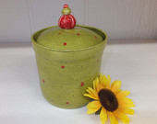

RESERVED FOR ROSY - Olive Green Ceramic Kitchen Canister with Red Dots, Handmade Stoneware Pottery Storage Jar, Wild Crow Farm Pottery
rebecca fenlon on Aug 29, 2016
1 out of 5 stars
Item not as described the lid did not even close to fit seller refused to pay return shipping I had to file a dispute to get my money back, horrible experience to say the least :(
Wild Crow Farm Pottery responded on Aug 30, 2016
As a small business owner, we have the privilege of choosing who we serve and do business with in the future. We have flagged your account due to your disrespectful and fraudulent claims, the return of severely damage products, and we will cancel any future orders you place with us.

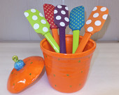

Orange Ceramic Canister, Polka Dotted Handmade Pottery Candy Jar, Wild Crow Farm Pottery
rebecca fenlon on Aug 29, 2016
1 out of 5 stars
Arrived with some broken in the set, seller refused to pay return shipping, what a nightmare this seller put me through never again would I purchase from them nor could I ever recommenced them :(
Wild Crow Farm Pottery responded on Aug 30, 2016
As a small business owner, we have the privilege of choosing who we serve and do business with in the future. We have flagged your account due to your disrespectful and fraudulent claims, the return of severely damage products, and we will cancel any future orders you place with us.

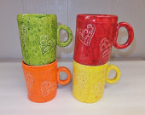

Set of 4 Ceramic Heart Coffee Mugs, Hand Built Stoneware Mugs, Wild Crow Farm Pottery
sparta603 on Aug 10, 2016
5 out of 5 stars
Gorgeous color and baked my berry crisp to perfection!

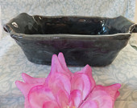

Handmade Ceramic Casserole, Midnight Rain Series, Wild Crow Farm Pottery, Bakeware
sparta603 on Aug 10, 2016
5 out of 5 stars
Love the rustic look of this pitcher!

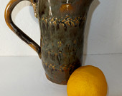

Ceramic Cream Pitcher, Olive Green Pottery, Rustic Handmade Stoneware, Wild Crow Farm Pottery
sparta603 on Aug 10, 2016
5 out of 5 stars
Beautiful lace mugs - nice big size for all the coffee and tea lovers in my family!

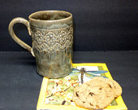

Extra Large Lace Mug, Hand Built Ceramic Pottery Mug, Wild Crow Farm Pottery
smbarclay1 on Aug 9, 2016
5 out of 5 stars
Love the yellow daisy spoon rest! It was packaged extremely well and arrived quickly. Would definitely order from Wild Crow Farm Pottery again. Thank you!!!

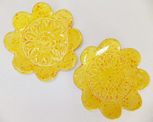

Yellow Daisy Ceramic Dessert Plate, Trinket Dish, Soap Holder, Spoon Rest, Wild Crow Farm Pottery
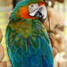
Beth Richardson on Aug 8, 2016
5 out of 5 stars
Beautiful and sturdy mug. Received very quickly.

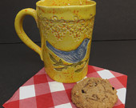

Large Blue Bird Coffee Mug, Hand Built Ceramic Stoneware Mug, Wild Crow Farm Pottery
Samantha Larson on Aug 5, 2016
5 out of 5 stars
Fantastic! This is a beautiful piece and the shipping was speedy.

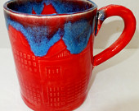

Large Red and Blue Ceramic Coffee Mug, Handmade Stoneware Pottery, Industrial City Series, Wild Crow Farm Pottery
Liz on Jul 27, 2016
5 out of 5 stars
A beautiful bowl, delivered quickly and packed well! Thanks!

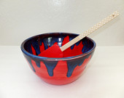

Large Red and Deep Blue Ceramic Serving Bowl, Stoneware Mixing Bowl, Wild Crow Farm Pottery
grace krajewski on Jul 26, 2016
5 out of 5 stars

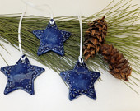

Blue Snowflake Ceramic Star Ornament, Ceramic Gift Tag,Wild Crow Farm Pottery
Crystal Waters on Jul 22, 2016
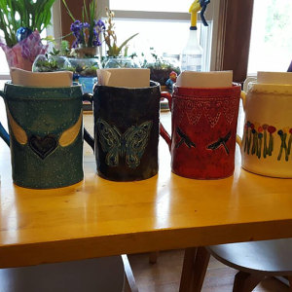
5 out of 5 stars
Custom mugs for my bridesmaids. Really great to work with. Amazing quality. Thank you so much!

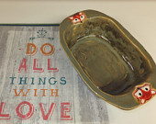

5 Custom Mugs
Sarah Sorensen on Jul 21, 2016
5 out of 5 stars

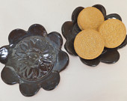

Daisy Ceramic Dessert Plate, Trinket Dish, Ring Holder, Wild Crow Farm Pottery
ambala on Jul 9, 2016
5 out of 5 stars
Oh WOW! I love everything about this piece; the colour, the spots, the shape and THAT gorgeous handle. The olive one is next and then ........... Thankyou Julie xxx

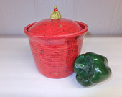

RESERVED FOR ROSY - Sale- Red and Olive Ceramic Kitchen Canister, Handmade Pottery Cookie Jar, Wild Crow Farm Pottery
Lysset on Jun 25, 2016
5 out of 5 stars

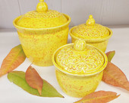

Yellow Daisy Ceramic Canister Set, Handmade Stoneware Pottery Storage Jars, Wild Crow Farm Pottery
ambala on Jun 17, 2016
5 out of 5 stars
OMG I forgot to write a review on this beautiful piece. I LOVE it.

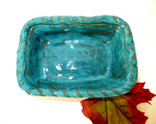

RESERVED FOR ROSY Turquoise Handmade Ceramic Bakeware, Wild Crow Farm Pottery, Stoneware Pottery Casserole
firegroupie431 on Jun 8, 2016
5 out of 5 stars
Gorgeous pie plate! I love the design. Really nice seller and very fast shipping. Thank you from a repeat customer.

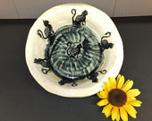

Pie Pan, Black Cats Home in From the Night, Handmade Stoneware, Wild Crow Farm Pottery

Andrea Squillini on Jun 6, 2016
5 out of 5 stars
Mug is beautiful and great size

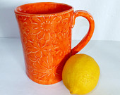

Large Orange Ceramic Coffee Mug, Hand Built Stoneware Flower Mug, Wild Crow Farm Pottery

Kelly Tshudy on May 19, 2016
5 out of 5 stars
Beautiful pottery. Thanks again. Shipping is super fast.

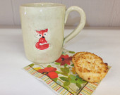

Little Red Fox Coffee Mug, Hand Built Ceramic Pottery Cup, Wild Crow Farm Pottery
Kelly Tshudy on May 18, 2016
5 out of 5 stars
Love the mug. Very neat! Like it so much that I bought another. Excellent service. Packaged perfectly with super fast shipping. Thank you.

Little Red Fox Coffee Mug, Hand Built Ceramic Pottery Cup, Wild Crow Farm Pottery
Cathy Draughn on May 15, 2016
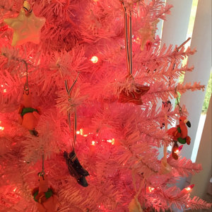
5 out of 5 stars
The picture does not do these red, white and blue stars justice. They are so cute. This was a custom order and the turn around was fast.

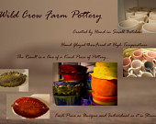

Patriotic Swirl Stars
GINGER on May 14, 2016
5 out of 5 stars

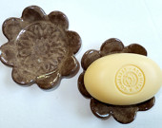

Rustic Brown Soap Dish,Trinket Dish, Ring Holder, Candle Plate, Dessert Plate, Spoon Holder, Wild Crow Farm Pottery

Lavinia Gambelli on May 9, 2016
5 out of 5 stars
I find it really cute! It was a successful present :) Thank you very much!

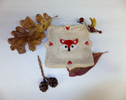

Red Fox Spoon Rest, Ring Holder, Tapas Plate, Ceramic Soap Dish, Wild Crow Farm Pottery

misscweed1 on May 5, 2016
5 out of 5 stars
Got it in plenty of time for a Mother's Day gift. Will give it to her Sunday. Mom loves soup and she likes having a handle to hold onto. Love the design. Thank you! Love the personal touch when receiving what I ordered!

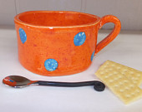

Large Orange with Blue Polka Dot Ceramic Soup Bowls , Rustic Handmade Stoneware Chowder Bowls, Wild Crow Farm Pottery
jessiesho on May 3, 2016
5 out of 5 stars
It was a pleasure to do business with Julie at Wild Crow Farm Pottery! I placed a custom order, and she delivered beautiful mugs in a timely fashion. If you're looking for mugs to treasure and enjoy for years to come, her creations are for you. And I can just feel the love she puts into her craft! Thank you, Julie!!

SPECIAL FOR JESSICA Blue Green Lace Ceramic Coffee Mug, Hand Built Stoneware Mug, Wild Crow Farm Pottery

Stephany Trammell on Apr 30, 2016
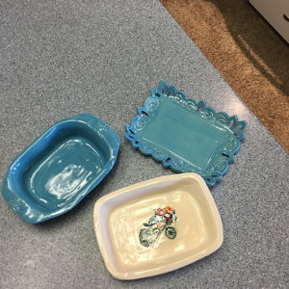
5 out of 5 stars
LOVE LOVE LOVE my new serving dishes😄

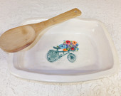

Aqua Blue Victorian Tray, Aqua Blue Bike Handle Casserole and Bike with Flower Basket Casserole
firegroupie431 on Apr 20, 2016
5 out of 5 stars
Really pretty pan. Very fast shipping and packed well. I love it! Great seller.

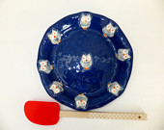

Handmade Ceramic Owl Pie Pan, Blue Owl Quiche Pan, Wild Crow Farm Pottery Bakeware
firegroupie431 on Apr 13, 2016
5 out of 5 stars
So cute! Very well packaged, so no damage. Extremely fast shipping. Thank you!!

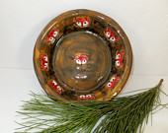

Red Fox Ceramic Deep Dish Pie Plate, Handmade Stoneware, Wild Crow Farm Pottery
Cecelia Steger on Apr 5, 2016
5 out of 5 stars
Lovely, solid, well made piece.

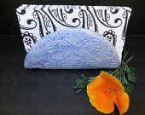

Blue Butterfly Ceramic Napkin Holder, Napkin Holder, Taco Holder, File HolderWild Crow Farm Pottery
erbarus on Apr 3, 2016
5 out of 5 stars
Love the plate! Thank you!

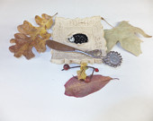

Little Hedgehog Spoon Rest, Soap Dish, Ring Holder, Tapas Plate, Wild Crow Farm Pottery

Faith Sentz on Mar 28, 2016
5 out of 5 stars

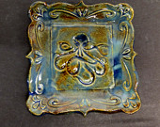

Octopus Soap Dish, Ring Holder, Tapas Plate, Spoon Rest, Wild Crow Farm Pottery
eliznitz on Mar 22, 2016
5 out of 5 stars
Awesome mug, love the size! Beautiful art, dishwasher safe, LOVE IT!

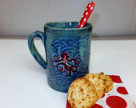

Large Octopus Mug, Hand Built Ceramic Pottery Mug, Wild Crow Farm Pottery
ambala on Mar 20, 2016
5 out of 5 stars
Gorgeous! Gorgeous! Gorgeous! No surprises here-your work is fantastic and true to the photos xxx. "See you," in 2 weeks Julie

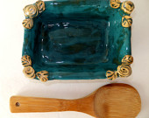

RESERVED FOR ROSY Handmade Ceramic Bakeware, Wild Crow Farm Pottery, Teal/Turquoise Kitchen, Stoneware Pottery Casserole

Mary Boynton on Mar 18, 2016
5 out of 5 stars
Arrived really quickly. Look fantastic. Thank you!

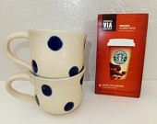

2 Blue Polka Dot Ceramic Mugs, Wild Crow Farm Pottery
Mary Gerber on Mar 4, 2016
5 out of 5 stars
Beautiful colors and crafting- carefully packed.

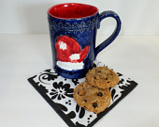

Red Winter Mitten Ceramic Coffee Mug, Hand Built Stoneware Large Pottery Mug, Wild Crow Farm Pottery
jschafer777 on Mar 1, 2016
5 out of 5 stars
Lovely & just the perfect size. Received very quickly.

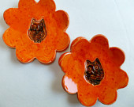

Orange Owl Ceramic Soap Dish, Ring Holder, Candle Plate, Dessert Plate, Spoon Holder, Wild Crow Farm Pottery
bethmerkin on Mar 1, 2016
5 out of 5 stars
large and whimsical and wonderful!!

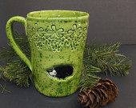

X-Large Lime Green Hedgehog Coffee Mug, Hand Built Ceramic Stoneware Tankard, Wild Crow Farm Pottery
Aleida Llanes-Oberstein on Feb 27, 2016
5 out of 5 stars
The bowl is beautiful! The packaging was terrific. Thanks!

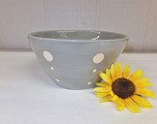

Gray Polka Dotted Ceramic Mixing Bowl, Stoneware Pottery Serving Bowl, Wild Crow Farm Pottery
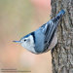
Laura Hill on Feb 23, 2016
5 out of 5 stars
Love the buttons and they were so nicely presented. Thank you! :)

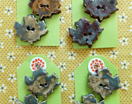

2 Maple Leaf Buttons, Handmade Ceramic Buttons, Wild Crow Farm
ERIN SMYTH on Feb 20, 2016
5 out of 5 stars
I loved my samples!!!! Thank you for carefully including design/color notes on each one and for the extra couple "surprise" samples tucked into my package. Your level of customer service is exemplary. I will be in touch soon with my next order!! Still torn between several of the blue color options????

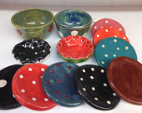

Sample Pack for Erin
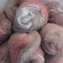
Kary on Feb 11, 2016
5 out of 5 stars
If I could give more than 5 stars .... I would! A beautiful piece and an awesome shop owner!! Thank you!!

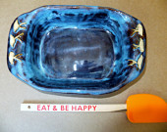

Sand Piper Ceramic Casserole, Blue Rustic Handmade Pan,Wild Crow Farm Pottery Bakeware

k57trjulie1 on Feb 10, 2016
5 out of 5 stars
I love Wild Crow pottery - packaged great and good shipping time.

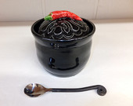

Black Chili Pepper Salsa Jar, Handmade Ceramic Lidded Jar, Wild Crow Farm Pottery
glif on Jan 29, 2016
5 out of 5 stars
Truly beautiful. Easy to drink from. Not too heavy. Very pleased with this item. Thank you.

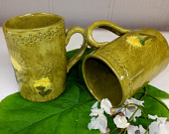

Extra Large Dandelion Ceramic Mug in Olive Green, Handmade Stoneware Coffee Cup, Wild Crow Farm Pottery
kbfairlie on Jan 27, 2016
5 out of 5 stars

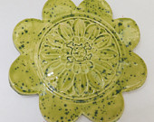

Lime Green Skull Ceramic Soap Dish, Candle Plate, Dessert Plate, Spoon Rest, Wild Crow Farm Pottery

Karen Skidmore on Jan 27, 2016
5 out of 5 stars

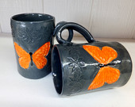

Gray and Orange Ceramic Butterfly Coffee Cup, Hand Built Stoneware Large Mug, Wild Crow Farm Pottery

KitMFalata on Jan 24, 2016
4 out of 5 stars
Pretty but smaller than I expected. Love the bees tho they're adorable.

Bees in a Mason Jar Spoon Rest, Ring Holder, Wild Crow Farm Pottery

Beth Dunlap on Jan 15, 2016
5 out of 5 stars

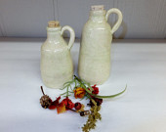

Small Stoneware Jug, Rustic Handmade Corked Ceramic Bottle, Wild Crow Farm Pottery
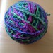
edecurtis on Jan 14, 2016
5 out of 5 stars
Perfect gift for four family members!

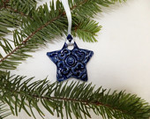

Blue Ceramic Star Ornament, Ceramic Pendant, Gift Tag, Wild Crow Farm Pottery
Christine Gurney on Jan 7, 2016
5 out of 5 stars
These are so cute! I got one for a friend and me to remind us no matter how bleak our work day may seem to get - "Life is Great!" Love it! Thank you! Super speedy delivery wrapped with TLC too!

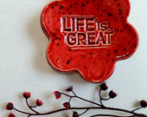

Life is Great Red Ceramic Trinket Dish, Spoon Rest, Tea Candle Holder, Wild Crow Farm Pottery
Linda Bennett on Jan 6, 2016
5 out of 5 stars
Lovely. Can't wait to give more out as gifts next year!

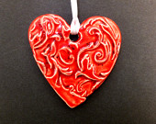

Red Heart Ornament, Ceramic Gift Tag, Valentine's Day Gift, Christmas Ornament, Wild Crow Farm Pottery
Linda Bennett on Jan 6, 2016
5 out of 5 stars
Great draftsmanship. My boyfriend loved the large coffee mug!

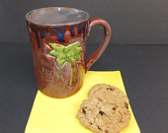

X-Large Life is Great Coffee Mug, Hand Built Ceramic Stoneware Tankard, Wild Crow Farm Pottery
Linda Bennett on Jan 6, 2016
5 out of 5 stars
Lovely gifts & addition to our tree. Came on time. .

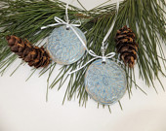

Blue Victorian Ceramic Ornament, Ceramic Gift Tag, Wild Crow Farm Pottery
sueannmunnell on Jan 5, 2016
5 out of 5 stars
Wonderful plate, beautiful presentation! I would recommend Wild Crow Farm Pottery to anyone.

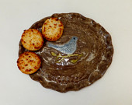

Blue Bird Ceramic Plate, Stoneware Serving Plate, Wild Crow Farm Pottery
tabby6957 on Dec 29, 2015
5 out of 5 stars
**THESE PRECIOUS RED STARS ARE WHAT STARTED IT ALL**WHEN I FOUND THESE & IMMEDIATELY BOUGHT THEM***I WAS SO EXCITED & JULIE WORKED A MIRACLE & GOT THEM HERE IN ONE DAY***LITTLE DID I KNOW SHE HAD 46 OTHER PAGES OF UNIQUE HAND MADE TREASURES**GOD & MY DAUGHTER IN HEAVEN LED ME TO THIS WOMAN**THERE IS NO DOUBT IN MY MIND *** ****EVERYTHING SHE MAKES IS FANTASTIC***THANK YOU JULIE FOR MY SPECIAL BUTTERFLY IN HONOR & IN MEMORY OF COURTNEY***SHE SAID SHE WOULD COME BACK TO VISIT AS A BUTTERFLY & YOU MADE THAT HAPPEN***YOU ARE A TRUE MIRACLE WORKER IN & OUT OF YOUR POTTERY ROOM***YOUR HEART OF GOLD HAS BROUGHT HOPE IN MY SOUL**WHAT MORE COULD A GIRL ASK FOR?? **STARS**MEATLOAF PAN** QUICHE PAN****LADY BUG CUP**SURPRISE BUTTERFLY**ALL TRUE GIFTS OF YOUR HEART & TALENTED HANDS***BLESS YOU***

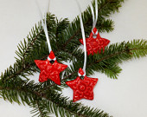

Red Ceramic Star Ornament, Gift Tag, Wild Crow Farm Pottery
tabby6957 on Dec 29, 2015
5 out of 5 stars
***THIS HANDMADE PAN IS SO INTRICATE WITH SUCH INCREDIBLE COLORS & DETAIL, IT SHOULD BE HANGING IN A MUSEUM***ONE AMAZING PIECE AFTER THE OTHER FROM JULIE***THE COLOR COMBINATIONS ARE EXQUISITE & THE DESIGN IN THE MIDDLE IS SO BREATHTAKING, I DON"T EVEN WANT TO COVER IT UP WITH A QUICHE*** ***BUT I WILL BECAUSE THIS WORK OF ART CAN GO RIGHT IN THE OVEN**DON'T YOU LOVE IT WHEN THAT HAPPENS?** ***SHE PACKS THESE TREASURES SUPER SAFE & SHIPS THEM SUPER FAST*SHE MUST BE FRIENDS WITH RUDOLPH* **THANK YOU & BLESSINGS TO YOU JULIE***WITHOUT A DOUBT, YOU ARE THE ONE WHO IS OOAK***

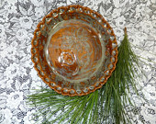

Handmade Ceramic Pie Pan, Rustic Stoneware Quiche Pan, Wild Crow Farm Pottery Bakeware
tabby6957 on Dec 29, 2015
5 out of 5 stars
***WHEN A LADY BUG LANDED ON MY DAUGHTER IN MY TRUCK & RODE WITH US FOR ABOUT AN HOUR ON HER ARM, IT WAS AMAZING***THIS GORGEOUS HANDMADE LADT BUG CUP IS ALSO AMAZING & IT HAD TO COME BE IN MY HOME IN HONOR & MEMORY OF MY DAUGHTER***SHE WENT TO HEAVEN EARLY, BUT SHE WOULD HAVE LOVED EVERY PIECE THAT JULIE HAS MADE IN HER WILD CROW FARM POTTERY***THESE COLORS & SHININHG IN THE SUN & THE DETAIL IS DELICATE & DAZZLING***THANK YOU***

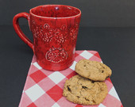

Red Ladybug Coffee Mug in Blue, Hand Built Stoneware Mug, Wild Crow Farm Pottery
tabby6957 on Dec 29, 2015
5 out of 5 stars
***THE COLOR COMBINATION OF THESE BOWLS IS SO CREATIVE***EVEN THOUGH MY PRECIOUS DAUGHTER WENT TO HEAVEN EARLY, I AM STILL BUYING THINGS AS THOUGH SHE WAS GOING TO USE THEM***THE SIZE OF THESE BOWLS IS PERFECT***THEY LOOK SO GORGEOUS SITTING UP ON MY SHELF***JULIE'S TALENT IN INCREDIBLE***THANK YOU, JULIE FOR SHARING YOUR TALENT WITH OTHERS***WE LOVE YOUR CREATIONS***

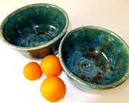

2 Ceramic Serving Bowls, Rustic Blue Green Stoneware Bowl Set, Prep Bowls, Wild Crow Farm Pottery
tabby6957 on Dec 29, 2015
5 out of 5 stars
***THE HAND SCULPTED RUFFLES ON THIS BEAUTIFUL IRISH GREEN CERAMIC LOAF PAN ARE INCREDIBLE*** ***OVEN SAFE IS MY FAVORITE & THIS WILL BE THE MOST CREATIVE PIECE AT ANY OF MY CHURCH FUNCTIONS***MY DAUGHTER WENT TO HEAVEN EARLY, BUT I GUARANTEE YOU SHE IS ADMIRING THIS FROM ABOVE***JULIE HAS TALENT IN HER HANDS & LOVE IN HER HEART & IT SHOWS IN HER WORK***SO GLAD I FOUND "WILD CROW FARM POTTERY***THEY ARE MY FAVORITE***BLESS YOU JULIE*** ***PACKED SAFELY & SHIPPED QUICKLY WAS A BONUS****

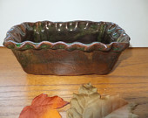

Ceramic Bread Pan, Loaf Pan, Irish Green, Wild Crow Farm Pottery, Ceramic Bakeware
Amanda Hofstaedter on Dec 29, 2015
5 out of 5 stars
Very fast shipping -- even close to the holidays! Lovely piece of pottery. Safely wrapped. Highly recommended!

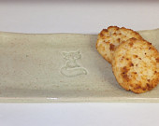

Fox Serving Tray, Hand Built Ceramic Pottery Tray, Wild Crow Farm Pottery
tabby6957 on Dec 23, 2015
5 out of 5 stars
***THE MOST MAGNIFICENT CERAMIC STARS YOU CAN EVER IMAGINE****JULIE IS A TRUE MIRACLE WORKER***** *****NOT ONLY ARE THE STARS DELICATE, MARVELOUS, DAZZLING & PRECIOUS, I THINK RUDOLPH BROUGHT THEM HIMSELF ON HIS WAY TO THE NORTH POLE****SOMEHOW, THEY GOT HERE IN ONE DAY****THE CREATIVITY FLOWS THROUGH THIS ARTIST'S HEART RIGHT INTO HER POTTERY* *****YOU MUST GO INTO WILD CROW FARM POTTERY***** ***YOU WILL BE THRILLED, SURPRISED, OVERJOYED, HAPPY, & TOTALLY SATISFIED WITH WHAT YOU WILL FIND*** **THIS WOMAN HAS PUT HOPE INTO A SHATTERED HEART** **DOES IT GET ANY BETTER THAN THAT ?*** ***IS THERE A WORD BETTER THAN PERFECT ?*** ***GOD BLESS THIS SELLER FOR SHARING HER TALENT***

Red Ceramic Star Ornament, Gift Tag, Wild Crow Farm Pottery
mjsconover4 on Dec 22, 2015
5 out of 5 stars
Working with Julie was delightful! She was just as excited as I about creating this special mug for my grandson. I received it in record time and am just waiting to hear from my 5 year old how his hot chocolate tastes out of his "big boy" mug! Thanks again for such a lovely, personal shopping experience.

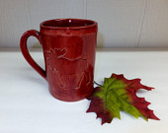

SPECIAL ORDER Charley's Brick Red Moose Ceramic Coffee Mug, Large Handbuilt Stoneware Pottery Mug, Wild Crow Farm Pottery
skypntr84 on Dec 19, 2015
5 out of 5 stars
All I can say is WOW! This pot is beautiful. The colors is vibrant. I can't wait to use it for shirred eggs and Mac & cheese. It's a perfect size for two people. Smiles all around!

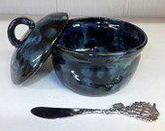

Small Blue Ceramic Casserole, Handmade Stoneware Pottery Storage Jar, Wild Crow Farm Pottery
Katie on Dec 15, 2015
5 out of 5 stars
Beautiful & well made. Can't wait to give it as a gift for Christmas!

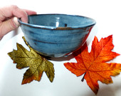

Primitive Blue Ceramic Serving Bowl, Wild Crow Farm Pottery
nancy s on Dec 15, 2015
5 out of 5 stars
Its a beautiful well made cup.

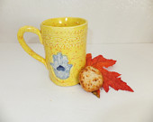

X-Large Yellow Hamsa Coffee Mug, Hand Built Ceramic Stoneware Tankard, Wild Crow Farm Pottery

hopemayes on Dec 14, 2015
5 out of 5 stars
This is a beautiful piece! I love it!! It also shipped very quickly! Thanks again!

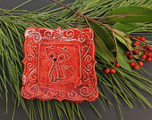

Ceramic Red Fox Spoon Rest, Ring Holder, Tapas Plate, Soap Dish, Wild Crow Farm Pottery
Sarah Mobley on Dec 13, 2015
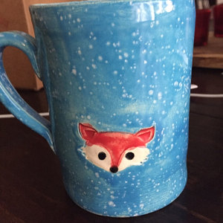
5 out of 5 stars
It's a large, adorable mug and is going to make an excellent Christmas present!

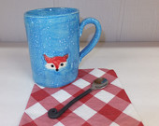

Red Fox Coffee Mug, Blue Hand Built Ceramic Pottery Cup, Wild Crow Farm Pottery
ambala on Dec 11, 2015
5 out of 5 stars
Gorgeous as ever! These cups/mugs are just so cute. Thankyou Julie xxx

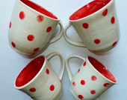

RESERVED FOR ROSY, 2 Large Ceramic Mugs, Red Dots on Cream, Wild Crow Farm Pottery, Red Kitchen

Krissy Fuselier on Dec 11, 2015
5 out of 5 stars
Just had to tell you my husband loved the mug! He's a sea boat captain and they drink a lot of coffee out there ;) Thanks so much for the beautiful mug and Merry Christmas :)

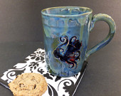

Large Blue Octopus Mug, Hand Built Ceramic Pottery Mug, Wild Crow Farm Pottery
Stephany Trammell on Dec 10, 2015
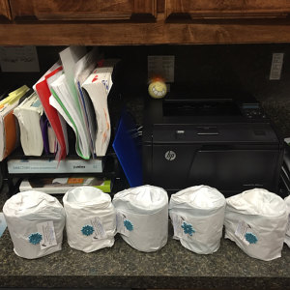
5 out of 5 stars
Looking forward to my staff arriving and finding these gorgeous mugs!! Absolutely gorgeous and I appreciate how they were wrapped during shipping!! Great job and will visit again!!!❤️

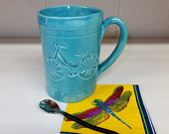

Aqua Ceramic Bike Coffee Mug, Handmade Stoneware Pottery, Wild Crow Farm Pottery

Grace on Dec 9, 2015
5 out of 5 stars
The mug is wonderful! It feels pleasantly heft in my hand and the design is perfect for my crow-obsessed partner. Shipped quickly with plenty of wrapping to ensure safe delivery. Thank you!

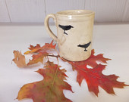

Crow Ceramic Coffee Mug, Hand Built Stoneware Mug, Wild Crow Farm Pottery
David Syot on Dec 7, 2015
5 out of 5 stars
Really cool mug for mother-in-law!

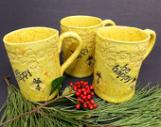

Large "Be Happy" Yellow Bee Coffee Mug, Hand Built Ceramic Stoneware Mug, Wild Crow Farm Pottery
Timothy Lohse on Nov 25, 2015
5 out of 5 stars
This is the perfect size mug I was looking for to hold a little more coffee than the standard size. I really like the extra detail above the dragonflys.

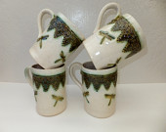

Large Dragonfly Coffee Mug, Hand Built Ceramic Pottery Mug, Wild Crow Farm Pottery
Timothy Lohse on Nov 25, 2015
5 out of 5 stars
Really nice mug! I bought it for my wife to remind her of the row of zinnias she plants every year by our front entry way. This will get her through the long winter.

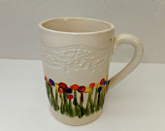

Large Ceramic Coffee Mug, Hand Built Stoneware Mug in Bright Flowers, Wild Crow Farm Pottery
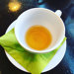
Beth Chapman on Nov 23, 2015
5 out of 5 stars
Lovely ornaments that ship fast and are beautiful!

Red Ceramic Star Ornament, Gift Tag, Wild Crow Farm Pottery
Beth Chapman on Nov 23, 2015
5 out of 5 stars
Lovely ornaments that ship fast and are beautiful!



Red Heart Ceramic Ornament, Pendant, Gift Tag, Wild Crow Farm Pottery

BabsarellaB on Nov 20, 2015
5 out of 5 stars
This is one of those items that is honestly even more impressive in person than in the photos. It's hard to tell in the photos that the octopi have beautiful little details in them that give the whole piece extra pow. Fast shipping, well-packed. Thank you!

Large Blue Octopus Mug, Hand Built Ceramic Pottery Mug, Wild Crow Farm Pottery

Matthew Arntzen on Nov 15, 2015
5 out of 5 stars
This is the perfect mug. Thanks!!

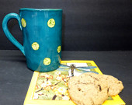

Extra Large Turquoise and Lime Green Polka Dot Ceramic Coffee Mug, Hand Built Stoneware Mug, Wild Crow Farm Pottery
carrie7777 on Oct 29, 2015
5 out of 5 stars
I love this napkin holder. Super unique and great quality. Very thankful I found this shop and they do excellent work!

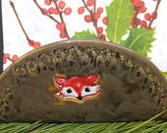

Red Fox Ceramic Napkin Holder, Napkin Holder, Taco Holder, File HolderWild Crow Farm Pottery
carrie7777 on Oct 29, 2015
5 out of 5 stars
Gorgeous! Perfectly packaged and a beautiful item. I love this shop! I can't wait to purchase more items for Christmas presents.

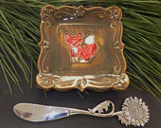

Red Fox Ceramic Spoon Rest, Ring Holder, Tapas Plate, Soap Dish, Wild Crow Farm Pottery
saffari331 on Oct 29, 2015
5 out of 5 stars
Very fast shipping and a well made stylish mug perfect for my large iced coffees.

Extra Large Turquoise and Lime Green Polka Dot Ceramic Coffee Mug, Hand Built Stoneware Mug, Wild Crow Farm Pottery
Jenny Mastantuono on Oct 28, 2015
5 out of 5 stars
Beautiful! I love how they arrive ready to be given as a gift and so quickly.

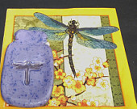

Dragonflies in a Mason Jar Spoon Rest, Ring Holder, Wild Crow Farm Pottery
Jenny Mastantuono on Oct 28, 2015
5 out of 5 stars
Beautiful and so carefully gift wrapped! As before, they arrived very, very quickly!

Dragonflies in a Mason Jar Spoon Rest, Ring Holder, Wild Crow Farm Pottery
ambala on Oct 21, 2015
5 out of 5 stars
Just the cutest cups. High tea here I come.

RESERVED FOR ROSY, 2 Large Ceramic Mugs, Red Dots on Cream, Wild Crow Farm Pottery, Red Kitchen
hillaryhlee on Oct 16, 2015
5 out of 5 stars
Love my new "cute as pie" mug! Excellent customer service. Thank you!

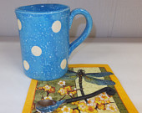

Extra Large Blue with Polka Dots Ceramic Coffee Mug, Hand Built Stoneware Mug, Wild Crow Farm Pottery
Brea Johnson on Sep 29, 2015
3 out of 5 stars
Smaller then I expected it to be.
Wild Crow Farm Pottery responded on Oct 8, 2015
Talked to Brea ~ She said that she loves this spoon rest and wanted to give a 4 star (still not a 5 star based on size) and couldn't re-do her review. We love our customers and want them to be very happy. I offered her a refund, but this item has found a good home and is loved. Sometimes, there are just different expectations on items. All sizes are included on the listings.

Dragonflies in a Mason Jar Spoon Rest, Ring Holder, Wild Crow Farm Pottery
Kbarry0330 on Sep 28, 2015
5 out of 5 stars
Fast shipping and mug was wrapped very well. Love it and would recommend!

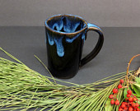

Small Handmade Black and Midnight Blue Ceramic Mug, Wild Crow Farm Pottery
Kathy Robinson on Sep 26, 2015
5 out of 5 stars
Really gorgeous mug. Looking forward to my morning coffee in it!

Large Red Dragonfly Coffee Mug, Hand Built Ceramic Pottery Mug, Wild Crow Farm Pottery
craftypropsmommy on Sep 25, 2015
5 out of 5 stars

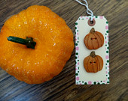

2 Ceramic Buttons,Stoneware Pumpkin Buttons, Craft Supply Buttons, Handmade Ceramic Buttons, Wild Crow Farm
egretspond on Sep 24, 2015
5 out of 5 stars
I love it. I don't have much money to spend on myself, but this was worth every penny. It brightens my counter and looks happy. Love the little top knob.

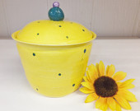

Yellow and Teal Polka Dot Ceramic Kitchen Canister, Handmade Pottery Storage Jar, Wild Crow Farm Pottery

Angela-Kevin Gordon on Sep 10, 2015
5 out of 5 stars
These are absolutely adorable! My little kitty loves them too :) Thanks so much for speedy shipment :)

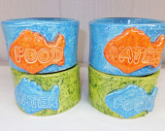

Cat Bowl Set, 2 Handmade Ceramic Pet Bowls, Wild Crow Farm Pottery
sarschec on Sep 4, 2015
5 out of 5 stars

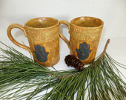

X-Large Hamsa Coffee Mug, Hand Built Ceramic Stoneware Tankard, Wild Crow Farm Pottery
Rajmund Zygadlewicz on Aug 25, 2015
5 out of 5 stars
Beautifully finished Little piece of art Made a great birthday present

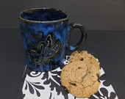

Black Blue Dragonfly Ceramic Coffee Mug, Hand Built Stoneware Mug, Wild Crow Farm Pottery

vic22301 on Aug 21, 2015
5 out of 5 stars
Fast shipping, great little piece. thanks!

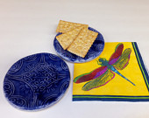

Oriental Blue Spoon Rest, Ceramic Ring Holder, Soap Dish , Wild Crow Farm Pottery
ambala on Aug 20, 2015
5 out of 5 stars
GORGEOUS-of course! I am always thrilled to receive pottery from this shop.

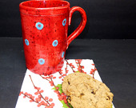

RESERVED FOR ROSY ~ Extra Large Red with Turquoise Polka Dot Ceramic Coffee Mug, Hand Built Stoneware Mug, Wild Crow Farm Pottery
cfm45 on Aug 8, 2015
5 out of 5 stars

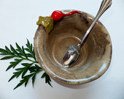

Red Radish Bowl, Rustic Handmade Pottery, Wild Crow Farm Pottery

Bronwen Griffiths-Barrasso on Aug 5, 2015
5 out of 5 stars
Stunning, gorgeous as ALWAYS!!! Thanks so so much. Bron xo

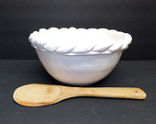

White Rustic Ceramic Serving Bowl, Large Rustic Hand Sculpted Pottery, Wild Crow Farm Pottery
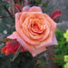
Pat Pierce on Jul 30, 2015
5 out of 5 stars

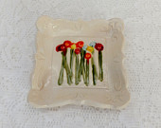

Flower Spoon Rest, Soap Dish, Ring Holder, Tapas Plate, Wild Crow Farm Pottery

thesilverpenny on Jul 17, 2015
5 out of 5 stars
Exactly what I wanted! It looks great on my dining table. The color in the photo was exactly what I received. I am very pleased!

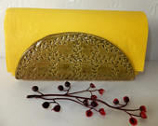

Olive Green Ceramic Napkin Holder, Wild Crow Farm Pottery
Jenny Mastantuono on Jul 7, 2015
5 out of 5 stars
This item arrived so quickly and it's beautiful! I love having such a unique item in my kitchen!

Dragonflies in a Mason Jar Spoon Rest, Ring Holder, Wild Crow Farm Pottery
Amy Esposito on Jul 7, 2015
5 out of 5 stars
Lovely bowl- a perfect gift!!

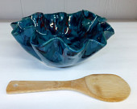

Deep Ocean Waves Rustic Ceramic Serving Bowl, Large Rustic Hand Sculpted Pottery, Wild Crow Farm Pottery
ambala on Jul 6, 2015
5 out of 5 stars
As always...perfect! I just love the richness this piece offers. My list was going down but has now gone up again...oh well!

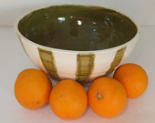

RESERVED FOR ROSY - Olive Green Striped Ceramic Serving Bowl, Stoneware Mixing Bowl, Wild Crow Farm Pottery
Jo Morgan on Jul 5, 2015
5 out of 5 stars
This is the perfect size for smoothies.

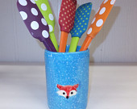

Red Fox Coffee Mug, Blue Hand Built Ceramic Pottery Cup, Wild Crow Farm Pottery
Jo Morgan on Jul 5, 2015
5 out of 5 stars
Perfect for breakfast smoothies.

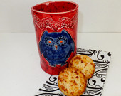

Blue Ceramic Owl Cup, Hand Built Pottery Tumbler, Wild Crow Farm Pottery
Jo Morgan on Jul 5, 2015
5 out of 5 stars
Use this every day! It's big enough to only make one trip.

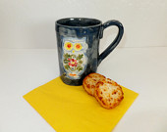

Large Blue Owl Coffee Mug, Extra Large Hand Built Ceramic Stoneware Mug, Wild Crow Farm Pottery
Jo Morgan on Jul 5, 2015
5 out of 5 stars
Just as described, and quite durable.

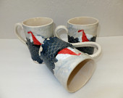

Sailboat Coffee Mug, Hand Built Ceramic Pottery Tumbler, Wild Crow Farm Pottery
Bronwen Griffiths-Barrasso on Jun 28, 2015
5 out of 5 stars
Stunning as always. Always thrilled. B

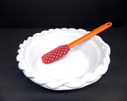

RESERVED FOR BRON ~ White Ceramic Pie Plate, Rustic Handmade Stoneware Pie Pan, Wild Crow Farm Pottery, Bakeware

mrsannasue on Jun 23, 2015
5 out of 5 stars
Beautiful, thank you for packing it so well!

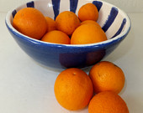

Blue and White Ceramic Serving Bowl, Rustic Handmade Stoneware Bowl, Wild Crow Farm Pottery

amandac1102 on Jun 19, 2015
5 out of 5 stars
I absolutely adore this Cardinal ornament!!! It is absolutely perfect! It is so, so cute! I LOVE it!!! I can not wait for Christmas, so I can hang it on my tree! You are so very talented!!! It was packaged really well and arrived quickly. It was a pleasure doing business with you!!!

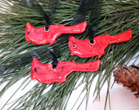

Red Cardinal Ornament, Ceramic Gift Tag, FREE U.S. SHIPPING, Wild Crow Farm Pottery

debbie combs on Jun 16, 2015
5 out of 5 stars
This is so adorable!! I hesitated on buying because it was a 'just for me' gift....but I am so glad I did...it's beautiful! And wow...fast shipping!!! Love it!!!!! Than you!

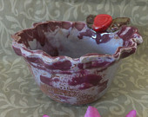

Purple Ceramic Bowl with Rose, Rustic Hand Built Stoneware Pottery, Wild Crow Farm Pottery

Robin Rhodes on Jun 9, 2015
5 out of 5 stars
Perfect mug for a beach loving friend!

Large Blue Octopus Mug, Hand Built Ceramic Pottery Mug, Wild Crow Farm Pottery
Robin Rhodes on Jun 9, 2015
5 out of 5 stars
An awesome mug for my granddaughter who loves to paint fox. Great craftsmanship!

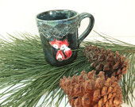

Blue Ceramic Red Fox Coffee Mug, Hand Built Stoneware Mug with Red Foxes, Wild Crow Farm Pottery
lulu122 on Jun 3, 2015
5 out of 5 stars
Love the bowls. They are just perfect. Thank you!

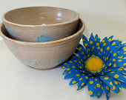

Ceramic Prep Bowls, Stoneware Nesting Dragonfly Bowls, Wild Crow Farm Pottery
lauraaroche on May 26, 2015
4 out of 5 stars
I thought it would be bigger. They should include diameter in description.

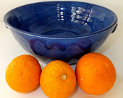

Blue Ceramic Serving Bowl with Handles, Wild Crow Farm Pottery
lauraaroche on May 26, 2015
4 out of 5 stars
I thought it would be bigger. They should include diameter in description.

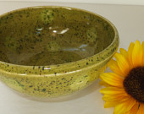

Green Handmade Ceramic Bowl with Dots, Rustic Stoneware Bowl, Wild Crow Farm Pottery
ambala on May 23, 2015
5 out of 5 stars
I adore this beautiful bowl. Everyone who has seen it loves it. I'll be buying for years to come; my list is HUGE!

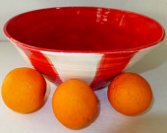

RESERVED for Rosy ~ Red and White Ceramic Serving Bowl, Rustic Handmade Stoneware Bowl, Wild Crow Farm Pottery

Sarah Baker on May 20, 2015
5 out of 5 stars
Beautiful item. The shipping was so fast, it seemed like I ordered it, blinked and it was here! I would stock my kitchen with items from this shop if I could afford it. Thank you!

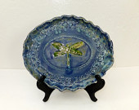

Dragonfly Ceramic Plate, Blue Green Stoneware Serving Plate, Wild Crow Farm Pottery
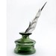
kellycm on May 19, 2015
5 out of 5 stars
Beautiful and shipping incredibly fast - lovely artist and seller to work with. My neighbor adored it. Thanks so much!

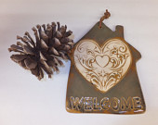

Welcome Home Wall Hanging, Ceramic Heart House Sign, Wild Crow Farm Pottery

Christine on May 19, 2015
5 out of 5 stars
Absolutely beautiful and wonderful seller,wrapped so beautiful and secure!!! Another very favorite seller and store!!

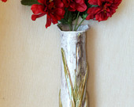

Ceramic Cattail Flower Vase, Rustic Handmade Minimalist Pottery, Wild Crow Farm Pottery

Kim Jankowiak on May 12, 2015
5 out of 5 stars
I couldn't decide between these and the other ladybug bowls so I ordered both for my mom- she loved these too!! Wonderful shop!!!

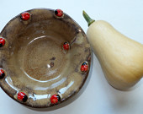

Ladybug Ceramic Bowl, Rustic Handmade Ladybugs, Wild Crow Farm Pottery
Kim Jankowiak on May 12, 2015
5 out of 5 stars
This was soooo cute. It was a gift for my mom who likes ladybugs and she LOVED these bowls. They arrived very quickly, were packed very well and securely. Lovely!! Thank you!!

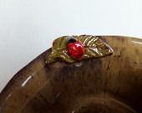

2 Ceramic Ladybug Bowls, Rustic Handmade Stoneware Pottery, Wild Crow Farm Pottery, Handmade Pottery
mwz5021 on May 12, 2015
5 out of 5 stars
Very fast shipping! Beautiful product that came exactly as described. You can tell the folks at Wild Crow Farm Pottery put a lot of care into what they make!

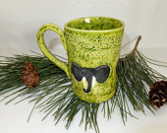

Extra Large Green Ceramic Elephant Coffee Mug, Handmade Stoneware Pottery Mug, Wild Crow Farm Pottery

Erica Warren on May 12, 2015
5 out of 5 stars
Very dainty, but does the trick!

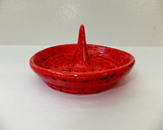

Red Ring Dish, Trinket Keeper, Red Jewelry Holder, FREE U.S. SHIPPING, Wild Crow Farm Pottery
ambala on May 8, 2015
5 out of 5 stars
I jumped for joy when I received my huge mug vases. I am absolutely thrilled! I have just ordered more because I love this unique style of pottery.

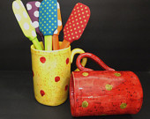

SPECIAL ORDER for Rosy ~ Extra Large Polka Dot Ceramic Coffee Vases, Hand Built Stoneware Mugs, Wild Crow Farm Pottery

Jamie Morris on May 5, 2015
5 out of 5 stars
Quick shipping. Beautiful piece, lots of character. Bought it for a gift, but would really love to keep it!

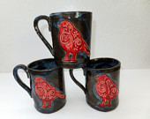

Red Bird Ceramic Coffee Mug, Hand Built Stoneware Pottery Mug, Wild Crow Farm Pottery
Heather on May 3, 2015
5 out of 5 stars

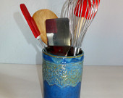

Blue and Green Ceramic Vase, Kitchen Utensil Holder, Handmade Pottery, Wild Crow Farm Pottery

holliesway09 on Apr 27, 2015
5 out of 5 stars
I LOVE this mug ❤️ it's original and huge, plenty of room for my morning coffee!!!! Brilliant service and delivery from USA to UK was super quick. THANK YOU 💖💖💖💖💖

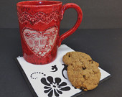

Red Ceramic Coffee Mug, Hand Built Stoneware, Sweetheart, Extra Large Pottery Mug, Wild Crow Farm Pottery
springwinter on Mar 26, 2015
5 out of 5 stars
I like the slightly not perfectly round shape and the color is beautiful. Design intricate but subtle. Well packaged and shipped promptly

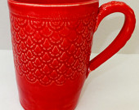

X-Large Red Ceramic Coffee Mug, Handmade Stoneware Pottery, Wild Crow Farm Pottery

91987idg on Mar 18, 2015
5 out of 5 stars
I loved this item when I found it.I have a friend who loves ceramic mugs and I loved the detailed patterns on the mug. Great craftsmanship.

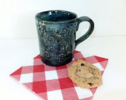

Midnight Blue Scroll Coffee Mug, Hand Built Ceramic Pottery, Wild Crow Farm Pottery
Christine Dernyar on Mar 18, 2015
5 out of 5 stars
Beautiful ceramic leaf pendant that will be utilized in a necklace that I am creating for myself. Good price with fast shipping.

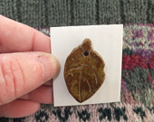

Ceramic leaf Pendant, FREE U.S. SHIPPING , Wild Crow Farm Pottery
Sarah McCalla on Mar 6, 2015
5 out of 5 stars
It's even more beautiful than the pictures show. Thank you!

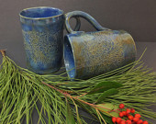

Blue Green Flower Coffee Mug, Hand Built Stoneware, Extra Large Pottery Mug, Wild Crow Farm Pottery

Lynne Zurowski on Mar 3, 2015
5 out of 5 stars
What a beautiful mug! I love it. It is my new favorite. My husband even commented on how nice it is. Shipping was quick. I placed the oder on Saturday, and it arrived on Monday.

X-Large Lime Green Hedgehog Coffee Mug, Hand Built Ceramic Stoneware Tankard, Wild Crow Farm Pottery

bev lane on Feb 25, 2015
4 out of 5 stars
great mugs, they brighten up my kitchen and make me smile.

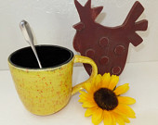

Yellow and Black Ceramic Coffee Mug, Wild Crow Farm Pottery

Adam Chantree on Feb 23, 2015
5 out of 5 stars
Bought it as a gift. Was pleasantly surprised with the elegant packaging, the included note about the history of the style of bowl, and of course the beautiful bowl itself. overall, very happy with the product, and service.

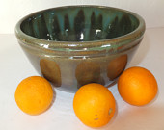

Rustic Green Ceramic Bowl, Stoneware Serving Bowl, Wild Crow Farm Pottery
Kathryn OConnor on Feb 17, 2015
5 out of 5 stars
Oh my gosh, in love! This is the cutest bowl! Can't rave enough about it, fast shipping, happy seller and really happy buyer!

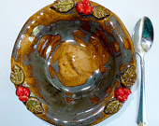

Ceramic Berry Bowl, Rustic Handmade Bowl, Wild Crow Farm Pottery, Farmhouse Kitchen, Spring Berries
Kathryn OConnor on Feb 17, 2015
5 out of 5 stars
I love these, perfect for my kitchen, cuter in person. They make me happy just to look at them. So excited to have purchased them! In love!

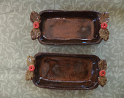

2 Ceramic Baking Dishes, Rustic Handmade Pottery Serving Trays,Wild Crow Farm Pottery Bakeware

Kim Nogueira on Feb 15, 2015
5 out of 5 stars
My favorite of the 3 I bought from you, but all are really awesome, thank you! And I should add that they came very quickly!

Sailboat Coffee Mug, Hand Built Ceramic Pottery Tumbler, Wild Crow Farm Pottery
Kim Nogueira on Feb 15, 2015
5 out of 5 stars
It is so hard to find an orange mug, but well worth the wait, thank you! I love the fabulous large size of this mug, and the others that I bought from you. I drink lots of tea, and it means so much to have hand made mugs now instead of the ones I had always bought from Marshalls--much better!

Large Orange Ceramic Coffee Mug, Hand Built Stoneware Flower Mug, Wild Crow Farm Pottery
Kim Nogueira on Feb 15, 2015
5 out of 5 stars
This mug makes me so happy, thank you! Your work is fabulous and my tea drinking has now been elevated to an art form!

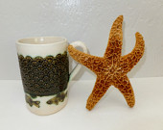

Large Coffee Mug, Fish Design, Hand Built Ceramic Pottery Mug, Wild Crow Farm Pottery
Sandra on Feb 6, 2015
5 out of 5 stars
Wow ~ The I Love You Dish arrived safely and super fast. The dish is beautiful and very well made. I love it. It will make a great dessert dish for Valentine's Day. Very smooth transaction ~ I highly recommend this seller. Thank you.

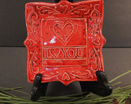

I Love You Dish, Spoon Rest, Valentine Ring Dish, Wild Crow Farm Pottery
jbaileyking on Feb 3, 2015
3 out of 5 stars
it is VERY small, sticks up on one side - not completely flat and the ladybug image is very small and disappointing.
Wild Crow Farm Pottery responded on Feb 9, 2015
This cute dish was refunded for customer satisfaction. Item was as described and photographed for size and motif.

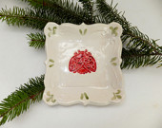

Little Ladybug Spoon Rest, Ring Holder, Ceramic Tapas Plate, Wild Crow Farm Pottery
karenmcwhirt1 on Jan 24, 2015
5 out of 5 stars
It's exactly right. Packaging is lovely I wanted it to have a message,but even better it had a story. thank you and your son. the quality is very nice,happy ,fun. I will shop more. Thank you

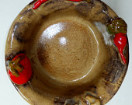

Ceramic Pasta Bowl, Rustic Hand Sculpted Vegetables, Stoneware Serving Bowl, Wild Crow Farm Pottery

Renee Jones on Jan 20, 2015
5 out of 5 stars
I love the deep red and blue.

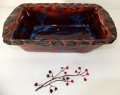

Spanish Lace Ceramic Bread Pan, Rustic Italian Kitchen, Handmade Stoneware Loaf Pan, Wild Crow Farm Pottery, Red and Blue
Dana Vass on Jan 11, 2015
5 out of 5 stars
The pottery was beautiful and it was shipped so carefully and protected !! Shipping was also extremely quick even around the holiday!

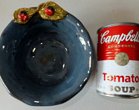

Blue Ceramic Ladybug Bowl, Rustic Handmade Soup Bowl, Wild Crow Farm Pottery
Melissa . on Jan 9, 2015
5 out of 5 stars
Perfect! I love it! I actually bought it for a friend and ended up giving it to another, now I need to buy another one. Beautiful and perfect!

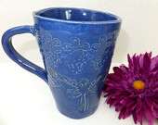

Blue Victorian Dragonfly Ceramic Mug, Blue Stoneware Coffee Cup, Wild Crow Farm Pottery
Courtney Austin on Jan 5, 2015
5 out of 5 stars
This is so cute! I love it, it has a perfect place in the center of my stove as a spoon rest. A little smaller than I expected, but works perfect all the same.

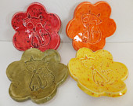

Foxy Ring Dishes, Spoon Rests, FREE U.S. SHIPPING, Wild Crow Farm Pottery
dana morgan on Jan 3, 2015
5 out of 5 stars
I have been eyeing your mugs for quite some time and decided to finally purchase one...I love the style: the color, glazing and design and the roughness and imperfections...it's beautiful! thank you..........................

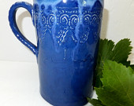

Extra Large Blue Cross Ceramic Coffee Mug, Handmade Pottery, Wild Crow Farm Pottery
Marcella Barboza on Jan 2, 2015
5 out of 5 stars
Perfect gift for daughter in law. thanks for quick delivery for Christmas.

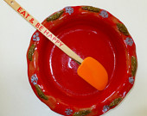

Red Deep Dish Pie Pan, Red Ceramic Quiche Pan, Wild Crow Farm Pottery's Red Farmhouse Kitchen

Kent Olinger on Dec 28, 2014
5 out of 5 stars
This mug made a perfect gift and the recipient loves it! Beautifully crafted and shipped quickly. Thank you so much!

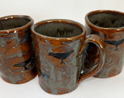

Black Crow, Large Coffee Mug, Black Raven Handmade Ceramic Mug, Wild Crow Farm Pottery
billotte4 on Dec 27, 2014
5 out of 5 stars
It's unique, color is bright, and it really looks like one of a kind.

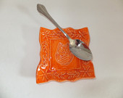

Orange Owl Spoon Rest, Ring Holder, Tapas Plate, Wild Crow Farm Pottery
ahoskins28 on Dec 26, 2014
5 out of 5 stars
Absolutely love this! Adorable and very detailed. So happy with my purchase! This would make a great gift! Also love the Christmas packaging :] Thanks so much!

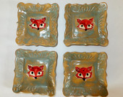

Ceramic Fox Plate, Spoon Rest, Ring Holder, Tapas Plate, Wild Crow Farm Pottery
Lauren Powers on Dec 26, 2014
5 out of 5 stars
Beautiful mug, very fast shipping.

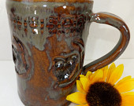

Extra Large Coffee Mug, Hand Built Ceramic Owl Mug, Rustic Stoneware Pottery, Wild Crow Farm Pottery
Will Rainwater on Dec 26, 2014
5 out of 5 stars
The wife really like it. She can't wait to use it.

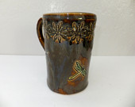

Dragonfly Coffee Mug, Extra Large Handmade Ceramic Pottery Mug, Wild Crow Farm Pottery
Nancy Jones on Dec 23, 2014
5 out of 5 stars
Love these ornaments! Julie was awesome to work with. She processed a very large order and delivered on time...despite a short timeline. She communicated with me and was a delight from start to finish. I highly recommend!

SPECIAL ORDER for Nancy ~Red Heart Ceramic Ornament, Pendant, Gift Tag, Wild Crow Farm Pottery
Adam Jensen on Dec 22, 2014
5 out of 5 stars
Looks really great. Shipped outrageously fast. Great transaction and a great shop.

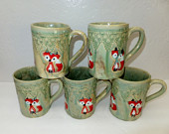

Large Ceramic Red Fox Coffee Mug, Hand Built Stoneware Mug with Red Foxes, Wild Crow Farm Pottery
kathy hackel on Dec 19, 2014
5 out of 5 stars
Was exactly as pictured. Thank you!

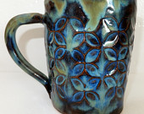

Large Blue Green Ceramic Coffee Mug, Rustic Farmhouse Hand Built Stoneware Pottery, Wild Crow Farm Pottery
Renee Jones on Dec 18, 2014
5 out of 5 stars
My daughter loved the Butterfly plate.

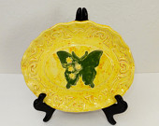

RESERVED FOR RENEE ~Yellow Ceramic Butterfly Plate, Stoneware Luncheon Plate, Wild Crow Farm Pottery
Renee Jones on Dec 18, 2014
5 out of 5 stars
It's beautiful and a nice size.

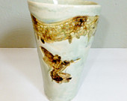

RESERVED FOR RENEE ~X-Large Hummingbird Cup, Crystalline Hand Built Ceramic Pottery Tumbler, Wild Crow Farm Pottery
andilm7 on Dec 16, 2014
5 out of 5 stars
Very pretty ornament. Thank you for the prompt shipment!

3" Red Heart Ornament, Party Favor, Ceramic Gift Tag, Valentine's Day Gift, Christmas Ornament, Wild Crow Farm Pottery
Sydney Holmes on Dec 15, 2014
5 out of 5 stars
I will definitely be purchasing from here again! My purchase was exactly what I saw in the pictures and it was wrapped and packaged so carefully! I could not be more happy with my purchase!!!

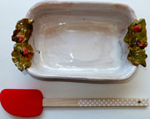

Ladybug Ceramic Casserole, Rustic Hand Built Brownie Pan,Wild Crow Farm Pottery Bakeware

Lauren Eddy on Nov 25, 2014
5 out of 5 stars
Beautiful items, great seller, and excellent customer service. The first item arrived broken in the mail and the seller was very courteous, and shipped a replacement promptly and free of charge, and it arrived super quickly! I'm very satisfied. Thank you!

SPECIAL LISTING for Lauren ~Red Heart Soap Dish, Spoon Rest, Ring Holder, Tapas Plate, Wild Crow Farm Pottery

cremer78 on Nov 5, 2014
5 out of 5 stars
Perfect. Exactly was I was looking for.

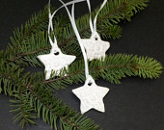

White Ceramic Star Ornament, Ceramic Pendant, Gift Tag, Wild Crow Farm Pottery
onlyonasunday on Oct 31, 2014
5 out of 5 stars
Beautiful coloring, perfect sized bowl for my needs, handcrafted, received quickly. Super nice working with Julie; ordered a few other pieces as well that I also love because they are made naturally with artistic design & colors, not mass produced. lve supporting artists & creatives whenever possible.

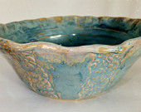

SPECIAL ORDER for Victoria ~ Blue Crystal and Ivory Serving Bowl, Large Hand Built Victorian Salad Bowl, Wild Crow Farm Pottery

Jenni Johnson on Oct 31, 2014
5 out of 5 stars
This ornament is so adorable! Thank you!

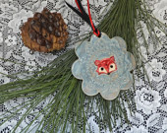

Fox Ceramic Ornaments, Ceramic Gift Tags, Wild Crow Farm Pottery

Cindy Micklos-Paulson on Oct 28, 2014
5 out of 5 stars
JUST LOVELY! This Etsy Seller is TOP NOTCH! Love the special details and the High Quality of her work! Super Communication and just a PERFECT Transaction all around! The Dragonflies Finally Landed !! :) and our Holiday Decor has a NEW PIECE! Thanks SO Much Julie!!

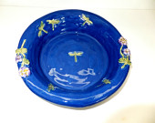

Blue Deep Dish Dragonfly Ceramic Pie Plate, Handmade Stoneware, Wild Crow Farm Pottery
onlyonasunday on Oct 26, 2014
5 out of 5 stars
Received the mug shown in Julie's Esty shop pic. I really like the colors & the artistic interpretation of grapes & leaves that decorate the mug. It arrived relatively quickly & was very well packaged for fragility with the other 2 pieces I'd ordered. Very rustic handmade pottery - there's something about that concept I like; it almost seems like a child's art project on the one hand, then has colors and artistic interpretations that are intriguing on the other. Will give the 2nd mug I ordered basically an identical rating.

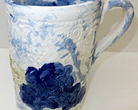

X-Large Blue Ceramic Coffee Mug, Hand Built Stoneware Pottery Cup, Mediterranean Grapes, Wild Crow Farm Pottery
onlyonasunday on Oct 26, 2014
5 out of 5 stars
Received the mug shown in Julie's Esty shop pic. I really like the colors & the artistic interpretation of trees that decorate the mug. It arrived relatively quickly & was very well packaged for fragility with the other 2 pieces I'd ordered. Very rustic handmade pottery - there's something about that concept I like; it almost seems like a child's art project on the one hand, then has colors and artistic interpretations that are intriguing on the other. Will give the 2nd mug I ordered basically an identical rating.

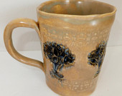

Large Ceramic Coffee Mug, Tree of Life, Hand Built Stoneware Pottery, Wild Crow Farm Pottery
Nancy Beaulieu on Oct 21, 2014
5 out of 5 stars
This is a sweet little pitcher - and it arrived in perfect condition!

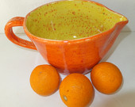

Orange Ceramic Pitcher, Stoneware Pancake Bowl, Wild Crow Farm Pottery, Small Neon Lemon and Orange Pitcher
carrie7777 on Oct 21, 2014
5 out of 5 stars
So pretty! It looks beautiful in my kitchen! A great piece I will treasure. Thanks!

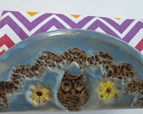

Blue Owl Ceramic Napkin Holder, Pottery Taco Holder, Wild Crow Farm Pottery

Michaela Kay on Oct 18, 2014
5 out of 5 stars
Love this! Great little coin/jewelry dish!

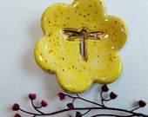

Yellow Dragonfly Dipping Bowl, Ceramic Ring Holder, Tea Candle Holder , Wild Crow Farm Pottery
Donna Kusterer on Oct 14, 2014
5 out of 5 stars
I adore my new mug! I can hardly wait to have my cup of coffee in it tomorrow morning! I will think of you wonderful craftsmen! Thank you so much! I am so happy!

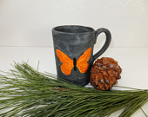

Gray and Orange Ceramic Butterfly Coffee Mug, Hand Built Stoneware Large Pottery Mug, Wild Crow Farm Pottery
cab2047 on Sep 18, 2014
5 out of 5 stars
this is a gift for a friend who loves pottery--this is so pretty---very quick shipping--packaged extremely well----am very happy with purchase---A+++++++++++++++++++++++++++++++++++++++++++++++++++++++++++++++++++++++

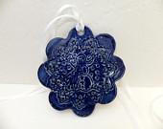

Blue Ceramic Snowman Ornaments, Ceramic Gift Tags, Wild Crow Farm Pottery
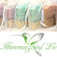
Shanna Anderson on Sep 16, 2014
5 out of 5 stars
I was thrilled to get my beautiful dish from Wild Crow Pottery. The dish was a pretty red and I love the designs and care they took to make and to package my order! They even sent a cute pottery ornament that was a huge surprise! Thank you <3 I highly recommend their shop.

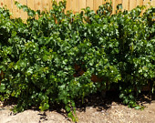

SPECIAL ORDER for Shanna Anderson
Donna Kusterer on Sep 15, 2014
5 out of 5 stars
I wanted a handmade big coffee mug and that's exactly what I got! The colors make me happy and the workmanship is impeccable!

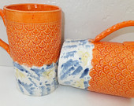

X-Large Orange Ceramic Coffee Mug, Handmade Stoneware Pottery with Bees, Wild Crow Farm Pottery
Ashley Poling on Sep 14, 2014
5 out of 5 stars
Beautiful! Thanks for the quick delivery. I bought this as a present and I think she will like it as much as me!

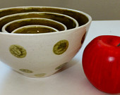

Green Ceramic Nesting Bowl Set with Dots, Stoneware Bowls, Wild Crow Farm Pottery
Ashley Poling on Sep 14, 2014
5 out of 5 stars
Beautiful! Thanks for the quick delivery. I bought this as a present and I think she will like it as much as me!

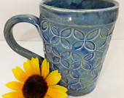

Extra Large Blue Green Ceramic Coffee Mug, Rustic Farmhouse Hand Built Stoneware Pottery, Wild Crow Farm Pottery
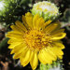
rumblebaker on Sep 5, 2014
5 out of 5 stars
Arrived in just a few days! For a friend's birthday! Looks great! She'll love it. :)

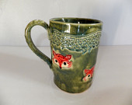

Large Ceramic Red Fox Coffee Mug, Hand Built Stoneware Mug, Wild Crow Farm Pottery
walkerlocker on Sep 4, 2014
5 out of 5 stars
Thank you!!! Nice product!!!! Came quickly.

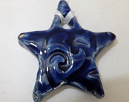

Blue Ceramic Star Ornament, Ceramic Pendant, Gift Tag, Wild Crow Farm Pottery

Nureen Hanisah on Aug 20, 2014
5 out of 5 stars
Lovely piece to put my rings and little pins on. Shipping was superb!

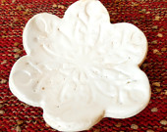

Winter Snowflake Ceramic Dipping Bowl, Trinket Dish, Party Favor, Ring Holder, Wild Crow Farm Pottery
meganstreet on Aug 18, 2014
5 out of 5 stars
beautiful! used as a soap dish in our guest bath and get tons of comments about it. thank you

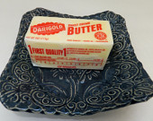

Blue Ceramic Soap Dish, Butter Dish, Rustic Blue Dessert Plate, Wild Crow Farm Pottery

smsstuart on Aug 12, 2014
5 out of 5 stars
Really nicely-crafted and finished napkin holder. Thanks.

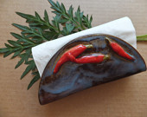

Chili Pepper Napkin Holder, Wild Crow Farm Pottery, Southwest Kitchen Hot Red Chili Peppers
fionawebster on Jul 24, 2014
5 out of 5 stars
Absolutely gorgeous! Wonderful customer responsiveness, too...

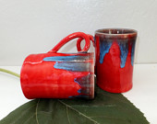

Red and Blue Ceramic Coffee Mug, Handmade Stoneware Pottery Cup, Wild Crow Farm Pottery
nenriquezschanowski on Jul 24, 2014
4 out of 5 stars
Unique and artful, love them!

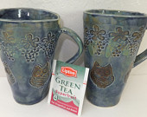

2 Large Blue and Green Owl Mugs, Hand Built Ceramic Pottery Mugs, Wild Crow Farm Pottery
Nancy Springer on Jul 10, 2014
5 out of 5 stars
These were one of a kind, I loved their character!

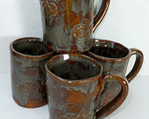

4 Handmade Stoneware Mugs, Bike Rider's Instant Ceramic Mug Collection, Beach Cruiser, Wild Crow Farm Pottery

shannon on Jun 24, 2014
5 out of 5 stars
beautiful work. I gave it as a gift to my sister and she uses it every day!

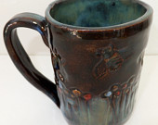

Large Blue Hand Built Ceramic Coffee Mug, Rustic Farmhouse Flowers and Bees Handmade Stoneware Pottery, Wild Crow Farm Pottery
lhausner1 on Jun 10, 2014
5 out of 5 stars
Had an issue with a gift I received. It was quickly and fairly resolved. Very happy with the outcome.

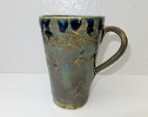

SPECIAL ORDER for Lynn Hausner - Do not order if this is not you - Replacement Blue Green Dragonfly Mug, Wild Crow Farm Pottery

Nikki Hantira on Jun 7, 2014
5 out of 5 stars
I have purchased from this shop several times. Everything she makes is amazing and Julie is a lot of fun to work with. Plus she ships super fast. Thank you so much :)

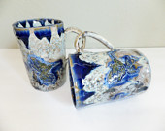

SPECIAL ORDER for Nikki - 2 Blue Crystalline Hummingbird Ceramic Mugs, Extra Large Victorian Stoneware Coffee Cups, Wild Crow Farm Pottery
Paula Ross on May 13, 2014
5 out of 5 stars
Super fast shipping! As described and super cute!

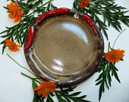

Chili Pepper Ceramic Luncheon Plate, Stoneware Serving Plate, Wild Crow Farm Pottery, Southwest Chili Peppers

vibrata on May 12, 2014
5 out of 5 stars
Adorable. Seller was so responsive and fast, and these bowls are adorbs! Thanks so much!!

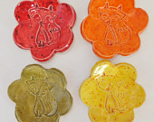

Set of 2 Ceramic Dipping Bowls, Foxy Trinket Dishes, Party Favors, Fox Ring Holders, Wild Crow Farm Pottery
Nikki Hantira on May 7, 2014
5 out of 5 stars
Although I have not actually seen the cups yet (gift for my sister) I know they are perfect, just like the first set I bought (for another sister). Owner is a delight to work with and her work is amazing.

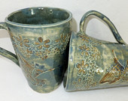

SPECIAL ORDER for Nikki Hantira ~2 Large Blue and Green Hummingbird Mugs, Hand Built Ceramic Pottery Mugs, Wild Crow Farm Pottery
mustang8 on Apr 3, 2014
5 out of 5 stars
Even cuter than it's picture! Personal note included and wrapped in tissue with a cute sticker. Fast shipping. Great purchase!

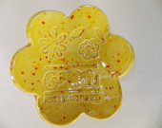

Ceramic Dipping Bowl, Trinket Dish, Party Favor, Ring Holder, Garden Grow Where You're Planted, Wild Crow Farm Pottery
Teresa Beevor on Mar 31, 2014
5 out of 5 stars
very beautiful and fast delivery

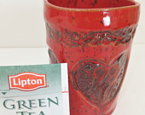

Red Hand Built Ceramic Heart Cup, Rustic Farmhouse Handmade Stoneware Pottery, Wild Crow Farm Pottery
Amy Kriger on Mar 30, 2014
5 out of 5 stars
I got this as a birthday gift for my mother, and she LOVED it! Thanks!

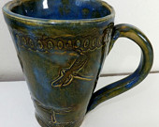

Large Blue Green Dragonfly Mug, Ceramic Stoneware Pottery Coffee Mug, Wild Crow Farm Pottery
Nikki Hantira on Mar 30, 2014
5 out of 5 stars
Very nice. Thank you much.

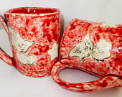

2 Large Red Hummingbird Mugs, Hand Built Ceramic Pottery tea Mug Set, Wild Crow Farm Pottery
Katie Christensen UnityPoint Hospice on Mar 28, 2014
5 out of 5 stars
Julie is very pleasant to work with and the order arrived quickly and stars are amazing qauliaty. Will definatly work with her again the future!

SPECIAL ORDER for Katie ~ Blue Ceramic Star Ornament, Ceramic Pendant, Gift Tag, Wild Crow Farm Pottery
Bronwen Griffiths-Barrasso on Mar 25, 2014
5 out of 5 stars
Adorable pottery and excellent service - second time I've brought from this seller, really love the work. B

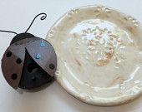

Mixed Clay Daisy Plate, Stoneware Serving Plate, Wild Crow Farm Pottery
Bronwen Griffiths-Barrasso on Mar 25, 2014
5 out of 5 stars
Adorable pottery and excellent service - second time I've brought from this seller, really love the work. B

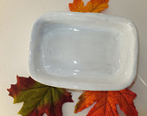

Rustic White Ceramic Casserole, Hand Built Brownie Pan,Wild Crow Farm Pottery Bakeware
Bronwen Griffiths-Barrasso on Mar 25, 2014
5 out of 5 stars
Adorable pottery and excellent service - second time I've brought from this seller, really love the work. B

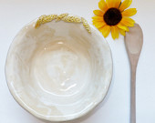

Ceramic Pasta Bowl, Rustic Hand Sculpted Grains, Stoneware Salad/Serving Bowl, Wild Crow Farm Pottery
Bronwen Griffiths-Barrasso on Mar 25, 2014
5 out of 5 stars
Adorable pottery and excellent service - second time I've brought from this seller, really love the work. B

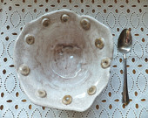

Ceramic Cereal Bowl, Handmade Stoneware Bowl, Wild Crow Farm Pottery's Farmhouse Kitchen, Fun Cheerio Bowl

Karen on Mar 12, 2014
5 out of 5 stars
Love the bees on this mug...makes my cup of tea more enjoyable..very well packaged and quick shipping

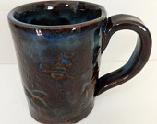

Hand Built Ceramic Coffee Mug, Rustic Farmhouse Honey Bee Handmade Stoneware Pottery, Wild Crow Farm Pottery

Elaine Tsai on Feb 27, 2014
5 out of 5 stars
Lightening fast shipping and a beautiful mug. I'm drinking tea from it right now. Thanks so much.

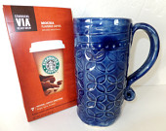

Blue Handmade Ceramic Coffee Mug, Tall Rustic Hand Built Stoneware Pottery, Wild Crow Farm Pottery
edbracegirl9 on Feb 23, 2014
5 out of 5 stars
beautiful work- thx so much!

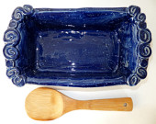

Handmade Ceramic Bread Pan, Rustic Dark Blue Stoneware Loaf Pan, Wild Crow Farm Pottery, Bakeware

Stacey Robertson on Jan 30, 2014
5 out of 5 stars
Very fast shipping, Beautifully packed, nice tightly packed and friendly. A pleasure to work with. Will definitely buy from again!

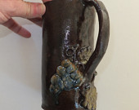

Big, Clunky Coffee Mug, Pottery Mug, Rustic Hand Built, Wild Crow Farm Pottery, Farmhouse Kitchen, Stoneware Tankard
Teresa Beevor on Jan 28, 2014
5 out of 5 stars
Beautiful mug, well made thank you!!!

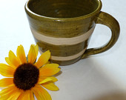

Large Olive Green Striped Ceramic Coffee Mug, Wild Crow Farm Pottery

John Abela on Jan 23, 2014
5 out of 5 stars
Wonderful piece and great service! Would buy again. Thanks!

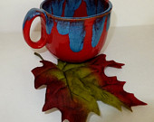

Intense Red and Blue Ceramic Coffee Mug, Wild Crow Farm Pottery, Gift Under 25
SusansAuctionsServ on Dec 19, 2013
5 out of 5 stars
Absolutely love the pottery - even better Seller -- was able to call me and confirm that it could be delivered for Christmas -- THANK YOU!!

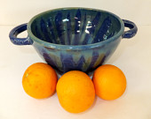

Ocean Blue Ceramic Bakeware, Stoneware Serving Dish, Wild Crow Farm Pottery, Farmhouse Kitchen Casserole
SusansAuctionsServ on Dec 19, 2013
5 out of 5 stars
Absolutely love the pottery - even better Seller -- was able to call me and confirm that it could be delivered for Christmas -- THANK YOU!!

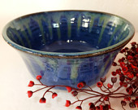

Large Blue Stoneware Serving Bowl, Mixing Bowl, Wild Crow Farm Pottery, Rustic Farmhouse Kitchen
SusansAuctionsServ on Dec 19, 2013
5 out of 5 stars
Absolutely love the pottery - even better Seller -- was able to call me and confirm that it could be delivered for Christmas -- THANK YOU!!

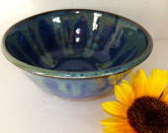

Blue and Green Ceramic Bowl, Rustic Stoneware Serving or Mixing Bowl, Farmhouse Kitchen, Wild Crow Farm Pottery
Terry Bonfiglio-Lopez on Dec 8, 2013
5 out of 5 stars
I purchased these as ring holders. They are the perfect size and match my décor, perfectly. Thanks for the great customer service and speedy delivery!

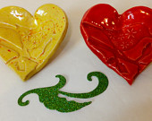

Set of 2 Ceramic Dipping Bowls, Trinket Dishes, Party Favors, Ring Holders, Hearts and Birds, Wild Crow Farm Pottery
Terry Bonfiglio-Lopez on Dec 8, 2013
5 out of 5 stars
This bowl is the cutest thing ever! It is currently holding potpourri in my home. I also think it would make a cute candy dish.

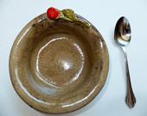

Ceramic Bowl, Rustic Handmade Rose, Wild Crow Farm Pottery, Gift Under 25, Seashore Brown
Terry Bonfiglio-Lopez on Dec 8, 2013
5 out of 5 stars
Love the heart and the great customer service!

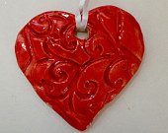

Ceramic Red Heart Ornament, Party Favor, Gift Tag, Valentine's Day Gift, Christmas Ornament, Wild Crow Farm Pottery

Grace on Nov 25, 2013
5 out of 5 stars
My kids love this pan! They can't wait for me to make bread in it. (I can't wait, either!) I am just thrilled with my purchase. I couldn't ask for better customer service or faster shipping! I will be back for more!

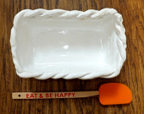

Handmade Ceramic Bread Pan, Rustic Italian Kitchen, White Stoneware Loaf Pan, Wild Crow Farm Pottery, Bakeware
Grace on Nov 25, 2013
5 out of 5 stars
Julie really goes the extra mile! I love this pan! I'm thrilled with my purchase. When it arrived, everything was wrapped so nicely -- it was just like Christmas! Every item I ordered was wrapped in bubble wrap & had little extra touches included. The shipping was super fast & the customer service couldn't be better!

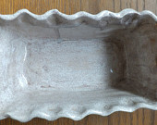

Ceramic Loaf Pan, Stoneware Bread Pan, Rustic Hand Built, OOAK, Wild Crow Farm Pottery Bakeware, Wine Country
Grace on Nov 25, 2013
5 out of 5 stars
I love this pan! I'm thrilled with my purchase. When it arrived, everything was wrapped so nicely -- it was just like Christmas! Every item I ordered was wrapped in bubble wrap & had little extra touches included. The shipping was super fast & the customer service couldn't be better! This is probably my favorite item. =)

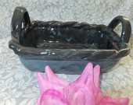

Handmade Ceramic Bakeware, Midnight Rains, Wild Crow Farm Pottery, Casserole
Grace on Nov 25, 2013
5 out of 5 stars
I love this pan! I'm thrilled with my purchase. When it arrived, everything was wrapped so nicely -- it was just like Christmas! Every item I ordered was wrapped in bubble wrap & had little extra touches included. The shipping was super fast & the customer service couldn't be better!

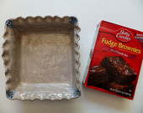

Ceramic Cake Pan, Stoneware Casserole, Brownie Pan, Wild Crow Farm Pottery Bakeware
Grace on Nov 25, 2013
5 out of 5 stars
I love this pan! I'm thrilled with my purchase. When it arrived, everything was wrapped so nicely -- it was just like Christmas! Every item I ordered was wrapped in bubble wrap & had little extra touches included. The shipping was super fast & the customer service couldn't be better!

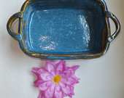

Ceramic Cake Pan, Stoneware Casserole, Rustic Hand Built Brownie Pan,Wild Crow Farm Pottery Bakeware
Barbara Nitke on Nov 22, 2013
5 out of 5 stars
Wow, I needed some mugs in a non standard size and was bowled over by the extremely attentive service I got from Wild Crow Farm. They made beautiful mugs and shipped them faster than I expected. Way beyond my expectations in every way!

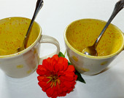

SPECIAL ORDER for Barbara Nitke - 4 Large Cappuccino Ceramic Mugs, Yellow Sunshine Dots on Cream, Wild Crow Farm Pottery

EMLAZAROU on Nov 11, 2013
4 out of 5 stars
The seller was great. The product is good quality and was wrapped perfectly. I wish I would have known how it would come out when I asked for a whole white bowl, but this isn't the seller's fault. She did exactly as I asked.

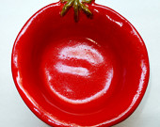

2 All White Custom Tomato Bowl
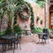
Terri Blackwelder Brandley on Nov 1, 2013
5 out of 5 stars
Absolutely gorgeous! Quick shipping, mint condition, good communication with seller. thanks so much!

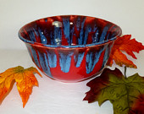

Handmade Rustic Large Ceramic Bowl, Red and Blue Stoneware Serving/Mixing Bowl,Wild Crow Farm Pottery
Terri Blackwelder Brandley on Nov 1, 2013
5 out of 5 stars
Absolutely gorgeous! Quick shipping, mint condition, good communication with seller. thanks so much! LOVE THIS BOWL ! :)

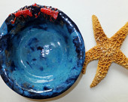

Blue Ceramic Lobster Bowl, Rustic Hand Sculpted Lobsters, Stoneware Salad/Serving/Pasta Bowl, Wild Crow Farm Pottery

Karma Grotelueschen on Sep 22, 2013
5 out of 5 stars
These bowls are very sweet and fun!

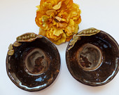

SPECIAL ORDER for Karma -Ceramic Salad Bowls, Rustic Handmade Pea Soup Bowls, Wild Crow Farm Pottery
Karma Grotelueschen on Sep 22, 2013
5 out of 5 stars
Lovely! Perfect for knitting projects!

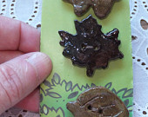

SPECIAL ORDER KARMA - Handmade Ceramic Buttons, Wild Crow Farm Pottery
Anonymous on Jul 31, 2013
5 out of 5 stars
Very pretty and unique.

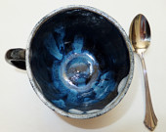

Alice's Midnight Mad Tea Cup, Ceramic Mug, Stoneware, OOAK, Black and Blue
Anonymous on Apr 27, 2013
5 out of 5 stars
Cute as can be - fast shipping- packaged well- thank you

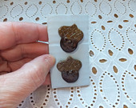

2 Ceramic Buttons,Stoneware Acorn Buttons, Craft Supply Buttons, Handmade Ceramic Buttons, Wild Crow Farm

